Kittitas County Public Health Department
Emergency Operation Plan

(Updated: 6/2018)

KITTITAS COUNTY PUBLIC HEALTH DEPARTMENT

The Kittitas County Public Health Department on this day hereby adopts this Kittitas County Public Health Department Emergency Operations Plan for emergency preparedness by majority vote of the Board of Health.

____________________ ______________________

Laura Osiadacz, Chair Obie O’Brien, Vice Chair

Board of Health Board of Health

____________________ _____________________

Cory Wright Rich Elliott

Board of Health Board of Health

____________________

Dr. John Asriel

Board of Health

Date ________________

It is the responsibility of the Kittitas County Public Health Department to prepare and maintain procedures and guidelines in order to provide KCPHD emergency preparedness staff training, exercises, and an updated emergency operation plan.



June 2018

The Kittitas County Public Health Department Emergency Operation Plan is a practical guide that helps you prepare for an emergency and defines your role and responsibilities as a department employee in the event of an emergency or disaster. The 2018 updated plan supersedes all previous emergency operation or emergency response plans.

As a Kittitas County Public Health Department employee, you are a vital and important member of the department’s Emergency Response Team. Without you, the careful plans and preparations we have made to provide assistance to our residents may not succeed.

This plan is designed to guide you in how to respond to emergencies and disasters as a first responder under the public health agency. As an employee, you are required to know the goals, roles, and responsibilities assigned to the public health department in the event of a disaster.

Even though we may not be able to prevent a disaster such as a catastrophic earthquake, we can be prepared. When disaster strikes, the speed and efficiency with which the department responds and the skill with which we perform our assigned duties will lessen the impact on the people of Kittitas County.

Your help and cooperation is greatly appreciated!

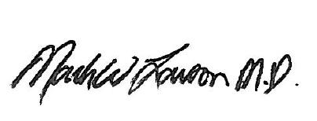

Dr. Mark Larson
Health Officer

Record of Changes |  |  |  | Change linked to AAR? Incident Name?
1. | 7.19.2011 | Sarah Bedsaul | Text formatting changes, updated officials information
2. | 1.22.14 | Kasey Knutson | Plan restructuring to follow Comprehensive Preparedness Guide 101 recommendations
3. | 6.30.2015 | Kasey Knutson  Zach Vavricka | Annual Updates  Addition of Point of Distribution forms, CD and EH annex, mass fatality annex.
4. | 9.10.15 | Kasey Knutson | Procedures defining how KCPHD will request assistance during disasters from the local Emergency Operations Center (EOC), neighboring LHJs, and DOH.
5. | 10.5.2015 | Kasey Knutson  Zach Vavricka | Added column to show revisions made that are linked to an AAR
6. | 10.5.2015 | Kasey Knutson  Zach Vavricka | Included decision making protocol language for health officer to make policy level decisions during emergency.
7. | 4.27.17 | Kasey Knutson | Updated general information about people with access and functional needs.
8. | 4.27.17 | Kasey Knutson | Language around rapid detection and response and addition of Annex L, which includes all MAA and MOU documents.
9. | 5.1.17 | Kasey Knutson | Added State DOH required information about situational awareness
10. | 5.12.17 | Kasey Knutson | Updated shipping and handling for 24/7 lab procedures to mirror KCPHD internal policy.  Added MOU and MAA info into Organization and Assignment of Responsibilities section.
11. | 5.22.17 | Tristen Lamb | Added COOP  Basic Formatting Changes
12. | 5.30.17 | Kasey Knutson | Spontaneous volunteer information added in Coordination, Control
13. | 11.27.17 | Kasey Knutson | Identified how to coordinate logistical issues for resources.
14. | 06.08.18 | Zach Vavricka | Updated Media Release templates

Record of Distribution
1. | 10.2.14 | Mary Small | Chelan Douglas Health District.
2. | 10.2.14 | Theresa Adkinson | Grant County Health District
3. | 10.2.14 | Jon Ness | Grant County Health District
4. | 10.2.14 | Douglas Hale | Okanogan County Health District
5. | 10.2.14 | Alma Castillo | Chelan Douglas Health District
6. | 10.2.14 | Dan Banks | Washington State Emergency Management
7. | 10.2.14 | Darren Higashiyama | Kittitas County Sheriff’s Office
8. | 10.2.14 | Rachel McKinlay | Washington State Department of Health
9. | 12.19.2016 | Concon deliverables email | Washington State Department of Health

Record of Exercises and Incidents
1. | 10.6.2010 | Annual Drive Thru Clinic | Ellensburg
2. | 10.1.2011 | Annual Drive Thru Clinic | Ellensburg
3. | 10.9.2012 | Annual Drive Thru Flu Clinic | Ellensburg
4. | 11.6.2012 | Annual Drive Thru Flu Clinic | Cle Elum/Roslyn
5. | 1.25.2013 | Flu/Pertussis Clinic | Ellensburg High School
6. | 10.17.2014 | Annual Drive Thru Flu Clinic | Ellensburg
7. | 10.30.2015 | Annual Drive Thru Flu Clinic | Ellensburg
8. | 10.21.2016 | Annual Drive Thru Flu Clinic | Ellensburg
9. | 10.20.2017 | Annual Drive Thru Flu Clinic | Ellensburg
10.
11.
12.
13.
14.
15.

TABLE OF CONTENTS
I. Purpose 9
II. Scope 9
III. Situation Overview 9-10
A. Hazard Analysis Summary 9
B. Capability Assessment 9
C. Limitations 9-10
D. Memorandum of Understanding/Mutual Aid Agreements 10

IV. Planning Assumptions 10-11
V. Concept of Operations 11-12
VI. Organization and Assignment of Responsibilities 12-14
VII. Direction, Control, and Coordination 14-16
VIII. Information Collection, Analysis, and Dissemination 17
IX. Communications 17
X. Administration, Finance, and Logistics 17
XI. Plan Development and Maintenance 17-18
XII. Authorities and References 18-28
XIII. Functional Annexes 29-109
A. 24/7 Laboratory Procedures 29-35
General Packing and Transportation Procedures 32-33
DOH Laboratory Certification 35
B. Isolation and Quarantine 36-43
C. Medical Countermeasures/Material Mgmt. 44-50
Medical Countermeasures Points of Distribution (POD) 51
POD Calculator 52
POD Agency Partnerships 53
Surge Capacity Staffing List 54
Patient Registration Form 55
Local Mass Clinic Facility Worksheet 56
Antiviral Withdrawal Form 57-58
D. Pandemic Flu Response 59-66
E. Emergency Communication Plan 67-
Press Release Template 70-71
Common Press Releases 72-75
Fax Machine Speed Dial Numbers 76-78
24/7 Emergency Contact List 79
Regional Satellite Phone List 80
Common Media Questions 81-82
Recording Hotline Greeting 83-84
Emergency Notification Tree 85
F. Shelter/Mass Care 86-87
Shelter-Tool form 88
G. Continuity of Operations (COOP) 89-96

Emergency Succession Plan 92-93
Organizational Chart 94
Identified Essential Services 95-96
H. Environmental Health 97-99
I. Communicable Disease —100-102
J. Mass Casualty 103-105
Death Certificate Process 106
K. Investigation Protocol 107-109

I. PURPOSE:
The purpose of the Kittitas County Public Health Department’s (KCPHD) Emergency Operation Plan (EOP) is to provide guidelines for coordinated preparedness and response to emergency incidents that fall under Emergency Support Function (ESF) 8, Public Health and Medical Services, or incidents that may have public health implications in Kittitas County.
II. SCOPE:
The plan is specific to KCPHD employees. KCPHD emergency response works in conjunction with the Kittitas County Comprehensive Emergency Management Plan (CEMP) in coordination with the Kittitas County Emergency Management Department as well as under the Regional lead of Public Health Emergency Preparedness and Response Region 7, including Chelan, Douglas, Grant, Okanogan, and Kittitas County.
III. SITUATION OVERVIEW:
A. Population estimates by the Office of Financial management as of April 1, 2017 put Kittitas County at 44,730. According to the US Census, approximately 8,224 residents are persons under the age of eighteen. In addition, Central Washington University (CWU) has 11,376 enrolled students. For People with Access and Functional Needs (PAFN), KCPHD has identified some general numbers, which will be annually updated and expanded:
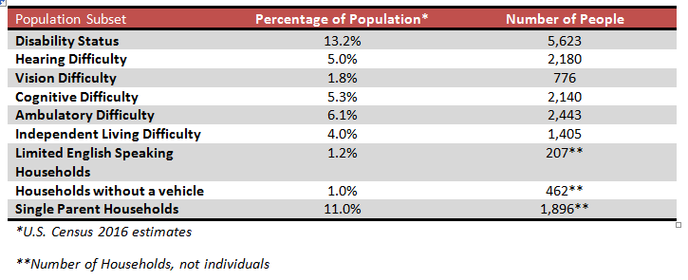

B. According to the Hazard Identification and Vulnerability Assessment (HIVA) 2012, completed by the Kittitas County Emergency Management, focus areas of potential emergency incidences range from civil disturbance to wild land fire.
C. KCPHD does not have adequate staff to respond to a community wide epidemic. KCPHD expects to receive assistance from local emergency management located within the Kittitas County Sheriff’s Office (KCSO), in addition to partners within Region 7. In the event of a pandemic or large incident, local response will be quickly overwhelmed and require mutual aid, state, and possibly federal assistance. If an incident results in the need for equipment or personnel, requests are made to the Kittitas County Emergency Operation Center (EOC) (Emergency Contact List in Annex E/Attachment C)
Limitations for requests for personnel or equipment include the following:
1. Damage to facilities and infrastructure
2. Transportation services
3. Staff availability
4. Damage to or disruption of communication systems
5. Fiscal constraints
6. Possible civil unrest
7. Other County/Local Agency Limitations
8. Other hazards may exist that are not addressed by this plan

D. The use of Memorandums of Understanding (MOU) and Mutual Aid Agreements (MAA) can mitigate some of the incident limitations. However, each situation or incident will dictate the extent that agreements will be implemented.

IV. PLANNING ASSUMPTIONS:

A. There is a surveillance system in place for the prompt detection, identification, and reporting of epidemic disease or a bioterrorism incident.

B. Individuals/institutions required to report disease are doing so within the time frame required by law.

C. Potential outbreaks/epidemics of disease are being investigated promptly and as required by statute.

D. KCPHD, Emergency Management, healthcare, law enforcement, emergency medical response, and other agencies will work cooperatively to reduce the impact of epidemic disease/bioterrorism in the community.

E. KCPHD staff is adequately trained to respond to epidemic disease.

F. Responders will be properly trained and issued the appropriate personal protective equipment, and are aware of the threat of a secondary incident. Within Kittitas County, responders will most likely be exposed to risks including physical injury, exposure to vaccine preventable diseases such as pertussis, chronic health problems if exposed to hazardous materials, as well as mental health issues resulting from disasters.

G. Governmental agencies and officials will respond as outlined in the appropriate Revised Code of Washington (RCW) and Washington Administrative Code (WAC).

H. In situations not specifically addressed in this plan, KCPHD and other emergency management officials will improvise and carry out their responsibilities to the best of their abilities using the Kittitas County Comprehensive Emergency Management Plan/Emergency Operations Plan.

I. Memoranda Agreements and Mutual Aid Agreements will be in place and honored between the organizations named in this plan and between neighboring governmental agencies.

J. As KCPHD may not have sufficient staff to respond adequately to an emergency situation, local agencies such as Kittitas Valley Fire and Rescue (KVFR) may partner with KCPHD to provide both staff support and logistical support.

V. CONCEPT OF OPERATIONS:

A. The Pre-Incident Phase
The pre-incident phase of an incident may be activated in the following ways:
1. National Terrorism Advisory System (NTAS)
a. Elevated – no specific information about timing or location of credible threat.
b. Imminent – if the threat is impending or very soon.
2. Kittitas County Sheriff’s Department/Emergency Management
3. KITTCOM – Kittitas County 911
4. Kittitas County Public Works
5. Complaint from the general public

B. Rapid Detection and Response
KCPHD works with various partners to ensure rapid detection and response of public health emergencies, including but not limited to the Kittitas County Sheriff’s Office, Region7 Partners along with Region 7 epidemiologist, and Washington State Department of Health, (Mutual Aid Agreements (MAA) and Memorandum of Understanding (MOU) documents are attached in Annex L). Notification of a potential incident or epidemic disease could happen in several ways:
1. Notification from regional, state, or national level authorities.
2. Notification by healthcare provider.
3. Notification by general public.
4. Notification by a law enforcement agency.
5. Detection by KCPHD staff.
6. KCPHD staff will notify Washington State Department of Health (DOH) in a timely manner of events or disease findings indicative of an emergency incident or an epidemic.
7. Increased surveillance may be necessary to confirm existence of an incident and KCPHD will use local healthcare providers, regional partners and State DOH as needed.
8. If indicated, KCPHD may activate its Emergency Coordination Center (ECC) to coordinate activities. The Incident Commander will be responsible for coordinating a response within the department in an emergency. The Incident Commander will determine the appropriate activation level, staffing, and roles. Incident Commander will utilize the Federal Emergency Management Agency’s (FEMA) Incident typing to determine activation of the EOP or activation of the ECC. Response will act according to the following incident types:
a. Type 5 – No incident Command System (ICS) staff activated.
b. Type 4 – Command/general staff activated, only as needed.
c. Type 3 – Some or all Command/general staff activated. Written Incident Action Plan (IA) may be required.
d. Type 2 – Regional resources required. Many Command/general staff positions filled. IAP required for each operational period.
e. Type 1 – National resources required. All positions activated. Written IAP required for each operational period.
9. If agencies other than KCPHD are needed to participate in disease control, the Health Officer/Commander may request activation of the county Emergency Operation Center.
10. Patient isolation and quarantine may be used per WAC 246-100-040 “Procedures for Isolation or Quarantine.” (Annex B).
11. Procedures for requesting laboratory support for establishment of diagnoses and to help determine the scope of the potential bioterrorism incident/epidemic disease are found in Functional Annex A, 24/7 Laboratory Procedures.
12. Healthcare support and mass casualty management: The Incident Commander will coordinate with Kittitas Valley Healthcare (KVH) and Emergency Medical Service providers to determine the ability of the local community to respond to the disease. If community resources are about to be or are already overwhelmed, the Incident Commander may request assistance through the Emergency Management Division. Request for assistance is completed through the Emergency Management office via the Kittitas County Sheriff’s Office. (Emergency Contact List in Annex E/Attachment C)

C. Recovery Phase
1. Environmental Restoration. Steps for environmental restoration may be determined at the time of the incident by the Incident Commander and the Command Staff, based on the Centers for Disease Control and Prevention (CDC) protocols for the organism or agent involved. The County Health Officer will give final approval for all protocols performed.
2. Re-entry Authorization. Re-entry authorization will be determined at the time of the incident by the County Health Officer or Health Officer designee. Determination will be based on CDC protocols for the organism or agent involved. The County Health Officer will give final approval for all protocols performed.

D. Surge Capacity
1. All KCPHD staff may be expected to respond to provide surge capacity. Training will be provided to personnel using Just in Time (JIT) training during the initial briefing. JIT will be performed by the Incident Commander or designee and will include relevant safety information as well as other necessary instructions.
2. Training to prepare KCPHD personnel will be completed via FEMA independent study courses. Additional training may include exercises with Region 7 partners, KCPHD annual emergency exercise, or additional FEMA trainings.
3. A staffing list for surge capacity to provide staffing needed and how KCPHD will fulfill those needs is provided in

VI. ORGANIZATION AND ASSIGNMENT OF RESPONSIBILITIES:

All emergency response activities will follow the National Incident Management System (NIMS) guidelines.

Health Officer: The Health Officer assumes a leading role during an incident involving bioterrorism, infectious disease, or other medical emergency. The Health Officer in consultation with the Public Health Administrator and Board of Health will decide policy, maintain contact with other agencies, and develop public health priorities. In all other emergency incidences, the Health Officer provides information and support to the Incident Commander as needed.
Resolution 2005-03 appoints an acting Health Officer from either Chelan-Douglas, Grant County, or Okanogan County) during the absence of KCPHD’s Health Officer for periods of leave, illness, or other excused absences at the written request of the County Administrator or the Chair of the Board of Health.
Other KCPHD Staff: Other KCPHD staff or trained volunteers, including Medical Reserve Corps (MRC) volunteers, will assume the appropriate NIMS roles
Kittitas Valley Healthcare: KVH will activate its Emergency Operations Center (EOC) and will be responsible for the coordination of the overall operations of the hospital in any disaster situation. KVH will have primary responsibility for staffing the hospital and will assist with any auxiliary areas created to manage the medical needs of the public during an emergency (i.e., mass casualties, quarantine and isolation, etc.). KVH will support an alternate care facility (ACF), if possible, through provision of medical expertise and resources.
Interlocal Cooperative Agreement for emergency storage of vaccine in the event of power or equipment failure at KCPHD. KVH will provide emergency storage for KCPHD’s vaccine.
Kittitas County Sheriff’s Office: Memorandum of Understanding in place to establish utilization of KCSO for the investigation, monitoring, and enforcement of disease investigations and other public health hazards, which also includes isolation and/or quarantine of a patient or patients.
KITTCOM (911): KITTCOM (911) shall serve as the primary notifier of bioterrorist incidents or other public health emergencies in Kittitas County, responsible for notifying the primary emergency service agencies, including public health.
Grant County People for People (211): Memorandum of Understanding in place to coordinate public health information during emergencies, provides non-emergency information about KCPHD services, and serves as a regional call center.
Walter Strom Middle School: Memorandum of Understanding in place to establish Walter Strom Middles School as a Point of Distribution (POD) to distribute medical countermeasure materials.
Kittitas County Emergency Medical Services System (EMS): Kittitas County Emergency Medical Services (EMS) System will facilitate the county’s transportation and pre hospital medical needs. The system consists of 11 licensed EMS agencies (primarily local fire departments) and 5 affiliated-level services. Coordination between licensed EMS agencies to meet the local EMS needs will be facilitated through KITTCOM and based on the Regional County Patient Care Operating Procedures and the Kittitas County Mass Casualty Incident Plan (MCI Run Cards). These documents are part of the South Central Region Trauma Plan, available through Kittitas County EMS.
Emergency Management: If a bioterrorism incident is suspected, KCPHD will make prompt notification to the Kittitas County Sheriff as the Director of Emergency management for Kittitas County. The Sheriff or his designee will direct the county EOC with the Health Officer assisting with direction, control, and management of the emergency as appropriate. Emergency Management will attempt to acquire the resources and supplies needed to respond to an incident when local resources are exceeded.
Local, County, and State Law Enforcement: Local and county law enforcement, Search and Rescue (SAR), and Fire District #1 will assist KVH and KCPHD with site security, perimeter control, and facility access. In an evacuation of the hospital, local, county, and state law enforcement agencies may be called upon to assist in the coordination of the evacuation. Should the need for an alternate care facility (quarantine or mass vaccination, etc.) or mass dispensing operations arise in Kittitas County, local, county, and state law enforcement may be requested to assist with site security, perimeter control, facility access, isolation and quarantine orders, and for the maintaining of order.
Region 7 Healthcare Coalition: Mutual Aid Agreement with partners in Okanogan, Grant, Chelan, Douglas, and Kittitas County to provide mutual assistance during emergencies to include personnel (includes Region 7 Epidemiologist), equipment (includes Alternate Care Facilities to address surge capacity), materials, supplies, facilities, services, and/or related resources.
Washington State Department of Health (DOH): DOH will coordinate statewide emergency planning and preparedness efforts and statewide surveillance activities. Samples collected by KCPHD will be tested by the public health laboratory network operated by DOH. DOH will coordinate with CDC and disseminate appropriate data and situation updates to KCPHD. DOH will coordinate development and implementation of disease containment strategies across multiple counties and regions within the state. DOH will supplement and support local effort to educate and inform the public about public health emergencies and preventative measures.

VII. DIRECTION, CONTROL, AND COORDINATION:
A. Kittitas County Public Health Department
1. During a bioterrorism, chemical, or radiological incident; communicable disease outbreak or public health emergency; KCPHD will respond based on the complexity of the incident.
2. KCPHD may activate the Emergency Coordination Center (ECC). (The ECC is located in room 115, with KCPHD Panaboard). However, there may be situations where KCPHD ECC is not activated. If the KCPHD ECC is not activated, the Kittitas County EOC will be used for operations.
3. All communications with the general public will be distributed through the Public Information Officer (PIO). If the EOC is activated, the PIO will coordinate messaging via the EOC.
4. Shifts during operation of Kittitas County Public Health Department ECC will normally be 12 hours during activation.
5. Security for the ECC will be provided by the Ellensburg Police Department, Kittitas County Sheriff’s Office, or Search and Rescue (SAR) if needed.
6. KCPHD will provide support to, and take guidance from, the Kittitas County EOC in public health emergencies. All public health activities will be coordinated with the Kittitas County EOC if KCPHD’s ECC is functioning.

B. Kittitas County Public Health Department Representation In On Scene Incident Command System
1. On-scene Incident Command representation will depend on which agency will have the lead in the incident.
2. If the incident is an actual bioterrorism incident, communicable disease outbreak, or public health emergency where a crime has been committed, law enforcement will be the lead agency. In this case, KCPHD will be represented on the Command Staff by the County Health Officer/Public Health Administrator, or a designee, who will be involved in various aspects of the response.

C. Coordination with Region 7 Public Health Agencies
KCPHD will immediately notify Chelan-Douglas Health District, headquarters for Region7 Public Health Agencies, when a bioterrorism incident is suspected or confirmed in Kittitas County. The Administrator of KCPHD will coordinate with Chelan-Douglas in determining when support personnel from the regional partners may be needed in Kittitas County.
D. Coordination with Region 7 Hospital Network
KVH will notify its Region 7 partners when a bioterrorism incident is suspected or confirmed in Kittitas County.
E. Coordination with Kittitas County Emergency Medical Services
Kittitas County falls under the South Central Region (SCR) Trauma Plan for regional planning and coordination. The request for resources from outside the county will be made through KITTCOM.
F. Coordination with Kittitas County EOC
Requests for assets to support a local emergency are made through the Kittitas County EOC. If the County EOC has not been activated, requests should be made directly to the Kittitas County Emergency Management Department via the Kittitas County Sheriff’s Office. Requests can be made via phone, email, or in person. All requests made with a declaration of emergency will be handled via Emergency Management. If the request cannot be handled locally, or through mutual aid, they are then sent to the Washington State Emergency Operations Center at the Washington State Emergency Management Division, Camp Murray, Washington.
If the request is specific to Emergency Support Function (ESF) 8, Public Health and medical, that desk will then address the issue as appropriate, working with the requisition agency to best meet that need. Washington State Department of Health serves as the lead for ESF 8 along with other state agencies in a supporting role.
The Kittitas County Emergency Management Department (KCSO) must be aware of any potential requests for assistance in order to determine the need for a declaration of emergency within the county. Resources received from DOH and other partners without a declaration of emergency will be handled by KCPHD and KCPHD will notify Emergency Management.
G. Health Officer
The Health Officer or designee may assume the role of Incident Commander during an epidemic disease or bioterrorism incident. The Health Officer, Public Health Administrator, and Board of Health will consult to decide policy pertaining to health and medical decisions during emergencies. The Health Officer in consultation with the Board of County Commissioners will make decisions if there is a financial implication to public health policy decisions during an emergency. The Health Officer may also maintain contact with other agencies, develop public health priorities, lead incident response, and delegate tasks. Managing spontaneous volunteers who may request to support the public health agency’s response either by incorporation or triaging to other volunteer resources.
H. Volunteers
KCPHD may utilize trained MRC volunteers or spontaneous volunteers for incidents that exceed our response capacity. The use of spontaneous volunteers will be coordinated with Kittitas County Emergency Management. All medical personnel must be verified using the Emergency System for Advance Registration of Volunteer Health Professionals (ESAR-VHP), or WA Serv, prior to volunteering. All volunteers will be required to sign and submit an Emergency Worker Registration Card and a Kittitas County Emergency Management Certificate of Authorization and Photograph and Media Consent form.
VIII. INFORMATION COLLECTION, ANALYSIS, AND DISSEMINATION:
Critical information that will be collected for situational awareness will include functionality of public health operations, healthcare facilities, infrastructure, along with number of disease cases and/or fatalities attributed to the incident. Additional information may include client or patient identification, location of client or patient, the identified potential or confirmed disease or health risk, date of onset, any related symptoms associated with the potential or identified disease, as well as individuals who may also have been potentially exposed. Sources of information may include local law enforcement, local healthcare providers, laboratories, KITTCOM, a complaint from the general public, national, state, or regional partner.
Collected information will be used only for the investigation and response of any identified disease threats or health risks. Information will be shared in accordance with the Health Insurance Portability and Accountability Act (HIPAA) regulations. Only emergency responders who are required to comply with HIPAA regulations will receive confidential medical information relating to the investigation or response.
IX. COMMUNICATIONS:
KCPHD has access to 24/7 support services and resources outside of the department, which require communication in a timely manner. Communication may be through various means including by fax, telephone landline, and in person requests. Communications procedures are outlined in the Communications Annex, Annex E.
Staff will be notified of an incident or mobilization either via the emergency phone tree, email, WA Secures, or in person.
X. ADMINISTRATION, FINANCE, AND LOGISTICS:
Memorandum of Understandings as well as local resources will be utilized first in response to emergencies. KCPHD and Kittitas County polices for financial accounting and auditing will be adhered to in regards to financial records, reporting, and tracking resources. All financial records will be kept in accordance with archiving requirements. Special purchasing policies under Kittitas County will require a Board of County Commissioners’ declaration of emergency in order to utilize.
XI. PLAN DEVELOPMENT AND MAINTENANCE:
A. KCPHD staff training regarding this plan will be performed regularly.
B. This plan will be exercised, evaluated, and updated at least once annually based on after action reports completed after KCPHD and/or county wide drills and exercises. Evaluations will include improvements as a result from exercise analysis completed and challenges identified. Updates will be based on recommended changes.
C. Recommended changes to this plan should be submitted to the Local Emergency Response Specialist at KCPHD, located at 507 N Nanum Street Suite 102 in Ellensburg, Washington, 98926. The phone number is 509-962-7515. Post exercise and or/incident debriefing will be utilized to review effectiveness and need for revision of this plan. The report will recommend changes, which if adopted, will be incorporated immediately.
D. At a minimum, this plan will be reviewed by the Kittitas County Emergency Management Council after annual review and the Local Emergency Response Specialist is responsible for the annual review of the Emergency Operation Plan. Updated plans must be sent to the Region 7 Emergency Response Coordinator and to the Kittitas County Emergency Management via Kittitas County Sheriff’s Office (KCSO).

XII. AUTHORITIES AND REFERENCES:
Primary Statutes Governing Public Health: Revised Code of Washington (RCW), Washington Administrative Code (WAC), Kittitas County Code (KCC)
RCW 70.58.020  246-490-010 | Deputy Registrar  Vital Records | Vital records means records of birth, death, fetal death, marriage, dissolution, annulment, and legal separation, maintained under the supervision of the state registrar of vital statistics.
43.20 State Board of Health  43.20.050 – powers and duties of state board of health  246-100 communicable and certain other diseases | Communicable and Certain other Diseases | To protect the health and well-being of the public by controlling communicable and certain other diseases.
RCW 70.05.070  246-100-036 | Local Health Officer- powers and duties | Enforce laws and control spread of disease within jurisdiction.
43.20.050  246-100-040 | Isolation and Quarantine | Local Health Officer may issue an emergency detention of a person or group of persons.
49.17 Washington Industrial Safety and Health Act  296-823  Occupational Exposure to Blood borne Pathogens | Blood borne Pathogens | Requires that all employees with occupational exposure participate in a training program that is provided at no cost to them and conducted during compensated working hours.
18.79  Nursing Care  246-840-700  246-840 Practical and Registered Nursing | Standards of Nursing Conduct or practice | Identify responsibilities of the professional registered nurse and the licensed practical nurse in health care settings and as provided in the Nursing Practice Act.
26.44 Abuse of Children  26.44.030 | Duty to report child abuse | When a healthcare professional has reasonable cause to believe that a child has suffered abuse or neglect, he or she shall report such incident, or cause a report to be made, to the proper law enforcement agency or to the department.
246-840 | Practical Registered Nursing | Licensing process and requirements of registered nurses.
RCW 70.28  246-170 | Tuberculosis (TB) | TB Prevention, Treatment, and Control
RCW 43.20.050  WAC 246-110-020 | Control of Communicable disease | Guidelines specific to controlling outbreak within a school and/or daycare.
43.20.050 (d and f)  70.05.070  246-215 WAC | Food Service | The purpose of chapter 246-215 WAC is to establish state board of health standards for food service under RCW 43.20.050 to promote and protect the health, etc. Chapter 246-215 includes 11 sections specific to food service.
43.20.050  RCW 69.06 Food and beverage establishment workers’ permit  246-217 WAC | Food Worker Cards | The purpose of chapter 246-217 WAC is to establish state board of health standards for the issuance of food worker cards (food worker permits) under chapter 69.06 RCW and RCW 43.20.050.  Chapter 246-217 includes 8 sections specific to food worker cards.  - RCW 69.06 includes 9 sections regarding service workers’ permits including validity, diseased persons, and limited duty permit.
KCC Title 8.041: Health, Welfare, and Sanitation  WAC 246-215 | Food Handling Rules and Regulations | The Board of County Commissioners hereby adopts by reference the Washington State Board of Health Rules and Regulations for Food Service Standards (Chapter 246-215 WAC) effective May 2, 2005, and as hereafter amended.  8.04.020 Penalty section regarding violation of 246-215 WAC.
KCC Title 8.08: Health, Welfare, and Sanitation | Health Permits – Food Handling Establishments | Establishes standards for permitting food establishments.
40.20.050  43.70.310  246-272A WAC On-Site Sewage Systems  WAC coordinates with RCW 18.210 and WAC 196-33 for design and RCW 36.70 and 58.17 for land use.  246-270 through 246-274 Sewer System WACS | On-Site Sewage | The purpose of the chapter is to protect the health by minimizing and regulating onsite sewage systems.
KCC Title 13.04: Water and Sewers | On-Site Sewage Disposal Systems | Protect public health by minimizing potential for public and ground water exposure to sewage from on-site sewage systems. Chapter 13.04 contains 31 sections from permitting to health hazards and health emergencies.
KCC Title 13.08: Water and Sewers | Private Sewage Disposal Systems in Plats | Chapter 13.08 contains 9 sections pertaining to plats connecting to septic tanks from applications to plat size requirements.
43.20  Public Law 93-523, the Federal Safe Drinking Water Act of 1974, and Public Law 99-339, the Safe Drinking Water Act Amendments of 1986, and certain provisions of Public Law 104-182, the Safe Drinking Water Act Amendments of 1996.  246-290 WAC | Public Water Supplies | Protect the health of consumers using public drinking water supplies by establishing requirements for persons operating small public water systems.  (1) The purpose of this chapter is to define basic regulatory requirements and to protect the health of consumers using public drinking water supplies.  (2) The rules of this chapter are specifically designed to ensure:  (a) Adequate design, construction, sampling, management, maintenance, and operation practices; and  (b) Provision of safe and high quality drinking water in a reliable manner and in a quantity suitable for intended use.  (3) Purveyors shall be responsible for complying with the regulatory requirements of this chapter.
43.20.050  70.05.070  70.116  70.119  246-291 WAC | Group B Public Water Systems | Protect the health of consumers using public drinking water supplies by establishing requirements for persons operating public water systems.  (1) The purpose of these rules is to define basic regulatory requirements to protect the health of consumers using Group B public drinking water supplies. These rules are specifically designed to ensure the provision of high quality drinking water in a reliable manner and in a quantity suitable for intended use.  (2) The rules set forth are adopted under chapter 43.20 RCW and owners of Group B public water systems shall be responsible for ensuring compliance with these rules. Other statutes relating to this chapter are:  (a) RCW 43.20B.020, Fees for services -- Department of health and department of social and health services;  (b) Chapter 43.70 RCW, Department of health;  (c) Chapter 70.05 RCW, Local health departments, boards, officers -- Regulations;  (d) Chapter 70.116 RCW, Public Water System Coordination Act of 1977; and  (e) Chapter 70.119A RCW, Public water systems -- Penalties and compliance.  (3) Prior to expanding a Group B public water system to a Group A public water system, the entire system shall be brought into compliance with chapter 246-290 WAC
70.116  Public Water System Coordination Act of 1977  246-293 WAC | Water System Coordination Act | This chapter is promulgated pursuant to the authority granted in the Public Water System Coordination Act of 1977, chapter 70.116 RCW, for the purpose of implementing a program relating to public water system coordination within the state of Washington, for evaluation and determination of critical water supply service areas, and assistance for orderly and efficient public water system planning.
70.54.010 | Polluting Water Supply | Authority to act when well, spring, stream, river or lake used for drinking water source is being polluted.  Authority to act when landlord is furnishing impure water.  Every person who shall deposit or suffer to be deposited in any spring, well, stream, river or lake, the water of which is or may be used for drinking purposes, or on any property owned, leased or otherwise controlled by any municipal corporation, corporation or person as a watershed or drainage basin for a public or private water system, any matter or thing whatever, dangerous or deleterious to health, or any matter or thing which may or could pollute the waters of such spring, well, stream, river, lake or water system, shall be guilty of a gross misdemeanor.
18.104 | Water Well Construction | The regulation and licensing of well contractors and operators and for the regulation of well design and construction. The legislature declares that the drilling, making or constructing of wells within the state is a business and activity of vital interest to the public. In order to protect the public health, welfare, and safety of the people it is necessary that provision be made for the regulation and licensing of well contractors and operators and for the regulation of well design and construction.
KCC Title 1320: Water and Sewers | Well construction and reconstruction | Allows the developer of a plat to bond for completion of the water system infrastructure.
246-272A-0320 WAC | OSS Regulations- Developments, subdivisions, and minimum land area requirements | Well Setbacks:  Prior to approving any development, the health officer shall require establishment of a 100 foot radius water supply protection zone to fit within the lot lines OR Establishes a wellhead protection zone around each existing or proposed well site. (1) A person proposing a subdivision where the use of OSS is planned shall obtain a recommendation for approval from the local health officer as required by RCW 58.17.150.  (2) The local health officer shall require the following prior to approving any development:  (a) Site evaluations as required under WAC 246-272A-0220, excluding subsections (3)(a)(i) and (4)(d);  (b) Where a subdivision with individual wells is proposed:  (i) Configuration of each lot to allow a one hundred-foot radius water supply protection zone to fit within the lot lines; or  (ii) Establishment of a one hundred-foot protection zone around each existing and proposed well site;  (c) Where preliminary approval of a subdivision is requested, provision of at least one soil log per proposed lot, unless the local health officer determines existing soils information allows fewer soil logs;
KCC Chapter 17A.08.025 | Well head protection areas | Well Setbacks: Wellhead protection areas. All non-community wells must be placed a minimum of fifty feet from property lines.
246-290-135 WAC & 246-291 WAC | Source Water Protection | Well Head Protection Zones: 1) The department may require monitoring and controls in addition to those specified in this section if the department determines a potential risk exists to the water quality of a source.  (2) SCA.  (a) The purveyor shall maintain an SCA around all sources for the purpose of protecting them from existing and potential sources of contamination.  (b) For wells and springs, the minimum SCA shall have a radius of one hundred feet (thirty meters) and two hundred feet (sixty meters) respectively, unless engineering justification demonstrates that a smaller area can provide an adequate level of source water protection. The justification shall address geological and hydrological data, well construction details, mitigation measures, and other relevant factors necessary to assure adequate sanitary control.  (c) The department may require a larger SCA than specified in (b) of this subsection, or additional mitigation measures if land use, geological, or hydrological data support the decision. It shall be the purveyor's responsibility to obtain the protection needed.  (d) The purveyor shall prohibit the construction, storage, disposal, or application of any source of contamination within the SCA without the permission of the purveyor.  (e) The SCA shall be owned by the purveyor in fee simple, or the purveyor shall have the right to exercise complete sanitary control of the land through other legal provisions.  (f) A purveyor, owning all or part of the SCA in fee simple or having possession and control, shall send to the department copies of legal documentation, such as a duly recorded declaration of covenant, restricting the use of the land. This legal documentation shall state:  (i) Constructing, storing, disposing, or applying any source of contamination is prohibited without the permission of the purveyor; and  (ii) If any change in ownership of the system or SCA is considered, all affected parties shall be informed of these requirements.  (g) Where portions of the control area are in the possession and control of another, the purveyor shall obtain a duly recorded restrictive covenant which shall run with the land, restricting the use of the land in accordance with this chapter and provide the department with copies of the appropriate documentation.
246-290-221 WAC | Water Demand Criteria | Minimal Daily Production of Well Water: (1) Except as provided in this section, expanding systems shall use water demand design for average day demand (ADD), and peak periods of demand such as maximum day demand (MDD), and peak hourly demand (PHD) that are based upon actual metered water use records. The data collected shall be sufficient to account for seasonal or other cyclic changes in water demand, and shall correlate to the maximum number of full-time or part-time equivalent residential units in service at any time.  (2) For seasonally used, transitory non-community, or recreational developments the design for ADD, MDD, and PHD shall be based upon metered water uses whenever such data is available. The data must account for the daily population using the water over the time that records are collected, and must reflect the uses associated with maximum occupancy for the development. The design demands for these developments apply only to part-time uses, and may not be applied to structures or dwellings that can be permanently occupied.  (3) In the absence of metered use or other comparable information, the following sources of design information may be used:  (a) Comparable metered water use data from analogous water systems. Analogous systems are those with similar characteristics, such as demographics, housing sizes, income levels, lot sizes, climate, water pricing structure, water use efficiency practices, use restrictions, and soils and landscaping; or  (b) Design criteria or guidelines in the most recent edition of the department manual for design of Group A public water systems.  (4) The design for water systems based upon metered water use records shall have an MDD no lower than three hundred fifty gallons per day per equivalent residential unit (ERU), except for the design of any expansion to an existing water system that has a minimum of two years of meter records that clearly demonstrate that a lower design value for MDD may be used without significant risk of pressure loss. The meter records must correlate the demand data to the actual level of occupancy for the periods covered by the records.  (5) The minimum water demand and duration required for fire flow and/or fire suppression storage shall be determined by the local fire control authority or chapter 246-293 WAC for systems within the boundaries of a designated critical water supply service area (CWSSA). Public water systems that are not required to comply with minimum fire flow standards shall coordinate with the local fire control authorities to ensure that any hydrants on the system, if they can possibly be used in the course of fire suppression activities, do not create adverse pressure problems within the water system as a result of fire control actions.
90.44 | Regulation of public ground waters (exempt wells) | Allows withdrawal of public ground waters for stock watering purposes, or the watering of a lawn or a noncommercial garden not exceeding ½ acre in area or for single or group domestic uses in an amount not exceeding 5000 gallons a day. Authority granting Department of Ecology to require water metering as well.
58.17.150 | Plats, Subdivisions, Dedications | Local health department or other agency must provide recommendations for approval or disapproval as to the adequacy of the proposed means of sewage disposal and water supply (before final plat approval).
58.17.060 | Short plats& short subdivisions | The legislative body shall provide that a short plat and short subdivision may be approved only if written findings that are appropriate as provided in RCW 58.17.110
58.17.110 | Approval or disapproval of subdivision | A proposed subdivision and dedication shall not be approved unless the county legislative body makes written findings that (a) appropriate provisions are made for the public health, safety, and general welfare and for potable water supplies.
246-272A-0320 WAC | OSS Regulations- Developments, subdivisions, and minimum land area requirements | OSS regulations for developments, subdivisions and minimum land areas.
KCC Chapter 16.12.150 | Road, sewer, water and fire system recommendations | The county health officer shall certify to the planning commission prior to the hearing their recommendations as to the adequacy of the proposed sewage disposal and potable water supply systems.
WAC 173-539A |  | Moratorium on use of ground water in upper Kittitas County. Requires water budget neutrality for land subdivisions.
KC Resolution 2004-36 | CDS administrative policy related to potable water supply for subdivisions | - Public Water Supplies – must be constructed, letter from purveyor  - Group B Public Water Supply – Well site inspection provided, Group B Workbook submitted and approved, well tag ID assigned approval from WA DOH.  Individual wells – well log or hydrogeological report required.
AGO 1997 No. 6, October 10, 1997 | WATER - WATER RIGHTS - WELLS - Status in water rights system of exempt ground water withdrawals | Provides interpretation of use of exempt ground water for subdivisions of land.
19.27.097 | Building permit application – Evidence of an adequate water supply – | Each building permit applicant of a building needing potable water shall provide evidence of an adequate water supply for the intended use of the building in the form of a water right permit from Ecology, letter from an approved water purveyor, another form sufficient to verify the existence of an adequate water supply.
365-196-825 (GMA) | Potable Water | Each building permit applicant shall provide evidence of an adequate water supply consistent with RCW 19.27.097 for a building needing potable water. If Ecology has adopted rules on this subject, or any part of it, local regulations should be consistent with those rules.
AGO 1992 No. 17-July 28, 1992 | Requirement of Adequate Water Supply before a Building Permit is Issued | The local building department must satisfy itself that the potable water source is reliable, of sufficient quality and quantity. This requires demonstration that water actually will be made available to the building for a reasonable period of time.
WAC 173-539A |  | Moratorium on use of ground water in upper Kittitas County. Requires water budget neutrality for building permits and requires metering for new residential connections and/or new use of exempt groundwater.
AGO 2002 No. 70279-9 28-March, 2002 | Campbell & Gwinn | Decision made by the Attorney General related to a case between Washington State Department of Ecology and local government about contiguous plats and use of exempt wells.
43.20.050  246-366 WAC | Primary and Secondary Schools | Maintain minimum environmental health and safety standards for school facilities until legislative action.
43.20.050  246-376 WAC | Camps | Requirements for environmental conditions in camps.
70.90.120  43.20.050  246-260 WAC | Water Recreation Facilities | Protect the health, safety, and welfare of users of water recreation facilities.
70.160 | Smoking in Public Places | To protect the health and welfare of all citizens, including workers in their places of employment, by prohibiting smoking in public places and workplaces.
KCC Title 8.24: Health, Welfare and Sanitation | Smoking in Public Places
70.05, 70.95  Chapter 173-351 WAC | Criteria for municipal solid waste landfills | Establish minimum statewide standards for all municipal solid waste landfill (MSWLF) units
70.05, 70.95  Chapter 173-303 WAC | Dangerous Waste Regulations | Establishes and designates sitting, design, operation, tracking, and handling responsibilities for hazardous waste management.
43.21A.080  91.11.090  70.95  173-312 WAC | Coordinated Prevention Grant | Provides guidance and funding to local health for monitoring and enforcing solid waste violations.
64.44  Chapter 246-205 WAC | Decontamination of Illegal Drug Manufacturing and Storage Sites | Requires local health agency to post warnings and supervise clean-up of contaminated properties
Chapter 246-203 WAC | General Sanitation | Establishes rules for public or common nuisances that are set up, maintained or continued so as to be injurious to the health or an obstruction to the use of property including disposal of dead animals.
RCW 59.18 | Residential Landlord Tenant Act | Requires local health jurisdiction to respond to complaints
70.94 | Washington Clean Air Act | Preserve, protect, and enhance the air quality for current and future generations
KCC Title 18: | Chapter 18. | Establishes enforcement actions for violations.

XIII. FUNCTIONAL ANNEXES:

Kittitas County Public Health Department
Laboratory Procedures Plan
Annex A
Table of Contents

I. INTRODUCTION 29
II. PLANNING ASSUMPTIONS 29
III. RESPONSIBILITIES 30
IV. CONCEPT OF OPERATIONS 30-31
V. ATTACHMENT 32-35
Attachment A General Packing and Transportation Procedures 32-34
Attachment B DOH Laboratory Certification 35

I. INTRODUCTION:
The use of laboratory services refers to classifying, handling, packing, and shipping hazardous materials to local, state, and/or private laboratories in order to identify disease agents and environmental health hazards. 24/7 Access to laboratory services will assist KCPHD in the surveillance of diseases or environmental health hazards affecting Kittitas County during outbreaks and emergency incidents.
II. PLANNING ASSUMPTIONS:
KCPHD has very limited capacity to collect specimens and has no testing capacity, internally. This plan applies to incidents requiring services that exceed the capacity of KCPHD as well as local health care providers and KVH. Local laboratory services will be overwhelmed in the case of an outbreak. The Washington State Department of Health Public Health Laboratories in Shoreline (accredited by the College of American Pathologists), Washington will be the main laboratory contact. During a statewide disaster, KCPHD may utilize out of state laboratory services. If a scene has been designated hazardous and a HAZMAT team is responding, KCPHD will not collect samples and will defer to the appropriate agency.
III. RESPONSIBILTIES:
A. KCPHD will be responsible for the following activities:
1. Initiating the use of laboratory services.
2. Choosing the appropriate laboratory site to utilize for testing.
3. Coordinating with the laboratory regarding supplies, shipping, and results.
4. KCPHD staff may collect the samples or coordinate with the public or agencies in the collection of samples.
5. KCPHD staff that collect samples will follow the appropriate collection method as listed by Washington State Department of Health or the Environmental Protection Agency, or other appropriate agency.
6. Receive testing samples including, but not limited to, samples involving stool, blood, sputum, nasal swabs, water, or wastewater.
7. Communicate with the appropriate laboratory regarding supplies, shipping, and testing results.
8. Act as courier for shipping and handling of specimens.
9. Ensuring staff are trained in Packaging and Shipping Division 6.2 materials and trained staff is available to send emergency biologics 24/7.
a. Staff members whose position may require them to handle and ship more dangerous Category A substances, and/or dry ice in quantities greater than 5.5 pounds, will complete formal training and receive a certificate in “Packaging and Shipping Division 6.2 Materials.” The training is available at no cost through the Centers for Disease Control (CDC) online at https://www.cdc.gov/labtraining/cdc-lab-training-courses/packing_shipping_62_materials.html, and periodically in person through the Washington State Department of Health, Public Health Laboratories (PHL). Currently, the positions requiring this training are the Community Health Supervisor, Public Health Nurses, and the Health Officer.

b. Formal training and testing is not required of staff members who only handle less dangerous Category B and Exempt substances. In this case, staff may receive training from other staff members trained as described in section II.B above.

IV. CONCEPT OF OPERATIONS:
A. KCPHD staff will follow internal policy around procedures for shipping and handling of hazardous materials.
B. KCPHD will coordinate with local labs such as KVH or other clinics within Kittitas County for laboratory collection of samples and specimens.
C. The local Health Officer, Community Health Supervisor, Environmental Health Supervisor, and/or Public Health Administrator will authorize the use of laboratory services for KCPHD submitted specimens or samples.
D. The above staff will initiate request for testing and the appropriate laboratory site.
E. In suspected bioterrorism situations, a law enforcement agency may transport the specimen directly to the laboratory site.
F. Staff will utilize emergency contact number list for laboratory 24/7 coverage, which is located in the Emergency Communication Plan annex. Should contact be unavailable via phone or email, staff will utilize alternate means of communication including SAT Phone or partner agencies for assistance such as Kittitas County Sheriff’s Office or ARES/RACES HAM radio operators.

Attachment A: General Packing and Transportation Procedures

1. The points of contact for shipping of laboratory samples for KCPHD are:
Primary: Community Health Supervisor
Alternate: Public Health Nurse
2. Questions on shipping of environmental and clinical samples should be directed to the Washington State Public Health Laboratory at (206) 418-5400 during business hours or (206) 418-5500, a 24-hour number.

3. The following are the general procedures for packaging and transportation of suspected bioterrorism and other infectious laboratory samples to the Washington State Department of Public Health Laboratory (WSPHL).
  - All suspected specimens that meet the criteria for submission must be coordinated with KCPHD first and then the Public Health Laboratory by calling (206) 418-5400 during business hours or (206) 418-5500 a 24-hour emergency phone number. No specimens will be accepted unless the Public Health Laboratory has been contacted prior to arrival of the specimen.
  - In suspected bioterrorism situations, local law enforcement, HAZMAT, Washington State Patrol, or an FBI representative will transport the specimen directly to the Public Health Laboratory at 1610 150th Street NE, Shoreline, WA 98155 (north of downtown Seattle). However, public health employees may also transport specimens as indicated.

Driving directions to the Washington State Department of Health Public Laboratories:
I-5 Northbound
Take NE 145th St. exit (Exit #175). After exiting, move to the far right lane. Turn right at the traffic light onto NE 145th St. (eastbound). Proceed in the left lane on 145th St. to the next traffic light at 15th Ave. NE. Turn left onto 15th Ave. NE, travel four blocks on 15th Ave. NE (northbound) to NE 150th St. Turn right onto NE 150th. You will see the state laboratories on the left at the intersection of 17th Ave. NE and NE 150th St.
I-5 Southbound
Take NE 145th St. exit (Exit #175). After exiting, stay in the left lane of the off ramp. Turn left at the traffic light onto NE 145th St. (eastbound). Proceed in the left lane on 145th St. to the next traffic light at 15th Ave. NE. Turn left onto 15th Ave. NE and travel four blocks until you reach NE 150th St. Turn right onto NE 150th St. You will see the state laboratories on the left at the intersection of 17th Ave. NE and NE 150th St. In cases where the specimen is shipped by commercial carrier, State and Federal shipping regulations pertaining to infectious substances must be followed.

- Packaging specimens for testing at the Washington State Department of Health Public Health Laboratories

- Infectious substances must be packaged and labeled according to certain specifications as outlined by the Washington State DOH Public Health Laboratories “packing and shipping of infectious substances.” Material must be packaged “to withstand leakage of contents, shocks, pressure changes and other conditions incident to ordinary handling in transportation.” The figure below shows how to triple package (primary receptacle, watertight secondary packaging, and durable outer packaging) according to the regulations.
- Primary Package
The primary receptacle contains the infectious substance and must be watertight to prevent leakage. These can be made of glass, metal, or plastic and should include screw-top tubes, flame-sealed glass ampoules, or rubber-stopped glass vials fitted with metal seals. Screw caps should be fastened with tape for extra safety.
- Secondary Package
One or more primary receptacles are placed in a water-tight secondary package. Absorbent material, sufficient to absorb the entire contents of the primary container(s), must be placed between the primary and secondary package. The secondary package should be labeled with name, address, and telephone number of the shipper.
- Outside Package
The secondary package is placed into the outer packaging, which must be of sufficient strength to contain and protect the contents within. Outer packages must be UN-certified, signified by having a UN specification mark on the outside of the package. Shipping regulations require that an itemized list of contents be placed between the secondary package and outer package.

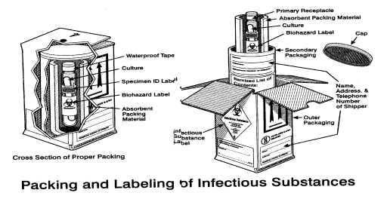Below is an example of packing for shipping of samples to the Washington State Public Health Laboratory.

Environmental Samples
Collection of environmental samples of concern is normally done by HAZMAT teams as part of their response to a contaminated scene. HAZMAT teams should follow their normal procedures for sampling and packaging of the materials.

- Clinical Samples
- Collection of diagnostic samples is normally done in clinical facilities. Confirmatory testing is done by WPHL. WPHL will perform confirmatory testing for the following diseases: Anthrax, Botulinum toxin, Tularemia, Plague, Brucellosis, Meliodosis, and Vaccinia.
- Confirmatory testing for smallpox is currently performed only by the CDC.
- Currently, DOH has guidelines for clinical laboratories for the following diseases: Smallpox, Anthrax, and Plague, Tularemia, and Botulinum toxin.

- Questions on shipping of environmental and clinical samples should be directed to the Washington State Public Health Laboratory at (206) 418-5400 during business hours or (206) 418-5500, a 24-hour number.

Attachment B: Washington State Department of Health Lab Accreditation Certification
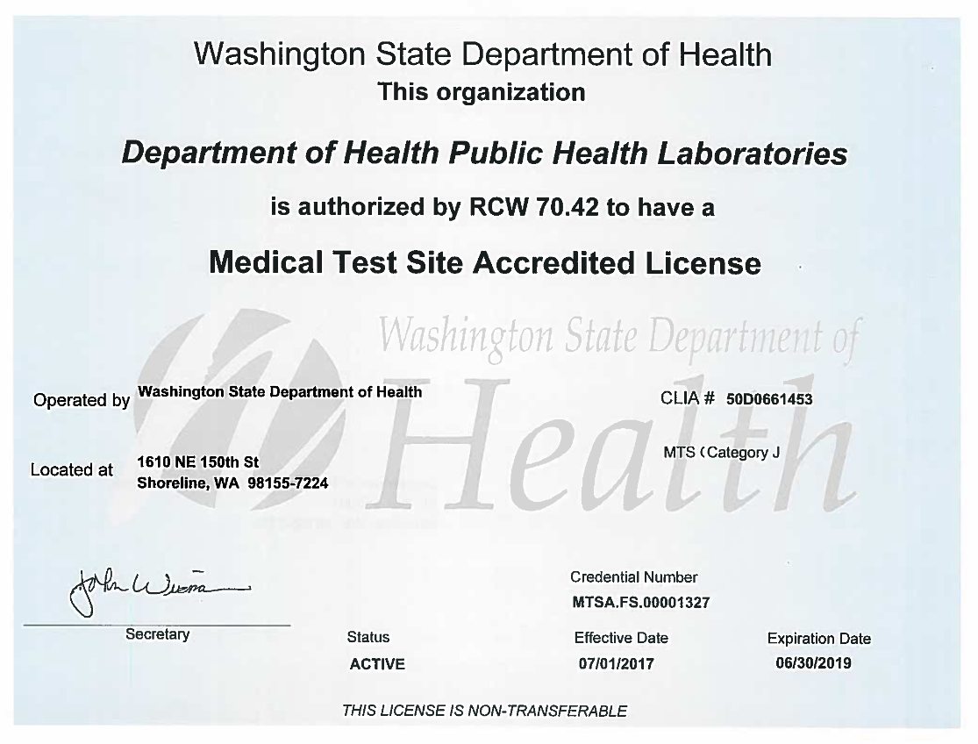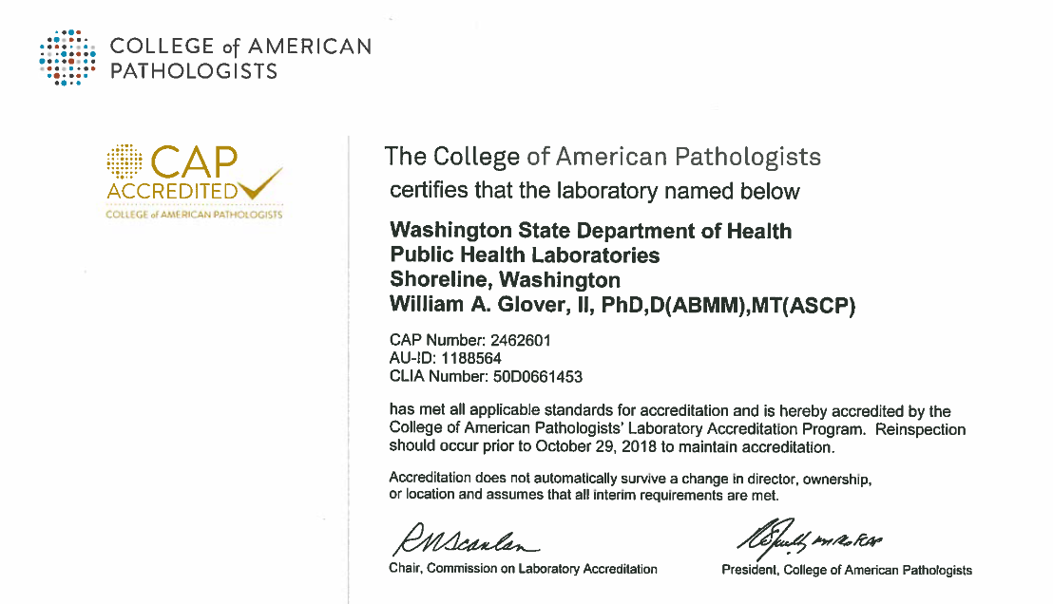
Kittitas County Public Health Department
Isolation and Quarantine
(Adapted from: Public Health – Seattle & King County Isolation and Quarantine Response Plan Version 2)
Annex B
Table of Contents

I. INTRODUCTION 37

II. PURPOSE OF PLAN 37

III. PLANNING ASSUMPTIONS 37-38

IV. RESPONSIBILITIES 38-39
A. Kittitas County Public Health Department
B. Local Law Enforcement
C. Prosecuting Attorney’s Office
D. Community Based Organizations

V. CONCEPT OF OPERATIONS 39-43
A. Determination of Need for Isolation or Quarantine
B. Initiation of Requests for Voluntary Compliance
C. Involuntary Detention
D. Release from Isolation or Quarantine

I. INTRODUCTION:

Isolation is the separation of infected persons from others during the period of communicability. Quarantine is the limitation of freedom of movement of well persons who are suspected to have been exposed to an infectious agent. Quarantine lasts as long as the usual incubation period of the infectious agent. Persons assigned to care for infectious or potentially infectious individuals must be protected as well as patients.

II. PURPOSE OF THE ISOLATION AND QUARANTINE RESPONSE PLAN:

A. Establish the decision making criteria used by the County Health Officer to determine when isolation and/or quarantine beyond the capacities of communicable disease practices is necessary to minimize health impact of a disease outbreak.

B. Identify the authorities, roles, and responsibilities of KCPHD and partner agencies in the situation of a disease outbreak requiring isolation and quarantine (I & Q) of one or more individuals.

C. Describe procedures and activities for accomplishing I & Q of large numbers of individuals in the county.

E. Describe procedures for staffing a dedicated facility for I & Q of persons who cannot stay in their homes or who do not have a suitable home environment.

F. Define roles and responsibilities for KCPHD, local health care partners, and local response agencies during an outbreak requiring isolation and/or quarantine.

G. Describe how communications and coordination will occur between KCPHD, local and state entities during such an incident.

H. Assist KCPHD and response partners to limit the spread of infectious diseases, illness, and death within Kittitas County.

III. PLANNING ASSUMPTIONS:

This plan applies to communicable disease occurrences requiring isolation and quarantine that may exceed day to day capabilities. While I & Q are techniques used in the everyday management of infectious disease, this plan does not apply to the prevention and control of sexually transmitted diseases, or routine operation of communicable disease management.

A. Isolation and quarantine planning efforts must incorporate and address the unique needs and circumstances of vulnerable populations including the homeless, limited English proficiency populations, persons with special medical needs, etc.

B. All policies and procedures to assure the care of protected health information apply. Policies and procedures recognize that KCPHD may make necessary disclosures to protect the health of the public.

C. Isolation and quarantine may be necessary beyond Kittitas County; therefore KCPHD will coordinate with other counties and regions, but is not responsible for planning or execution of I & Q efforts beyond county lines.

D. Large scale I & Q incidences will require many public health resources and volunteers as well as coordination with multiple communities, health care and first responder agencies.

E. KCPHD may utilize I & Q as one of several tools to reduce the spread of communicable disease; KCPHD will focus on gaining voluntary compliance from ill or exposed persons and implementing the least restrictive means possible to reduce the spread of infection.

F. KCPHD will coordinate closely with healthcare providers and healthcare facilities to assist with achieving voluntary compliance of ill or exposed persons.

G. I & Q may require the involuntary detention of individuals who may pose a threat to the public’s health and whom do not cooperate with requests from the Health Officer.

H. An individual’s cooperation with voluntary isolation and quarantine will be assumed in good faith unless there is evidence to the contrary. Depending on the circumstances, information collected by KCPHD during monitoring may be used as evidence of non-cooperation.

VII. RESPONSIBILITIES:

A. In the event of a reported or suspected case of a communicable disease, which requires isolation or quarantine, the Health Officer may at his or her sole discretion issue an emergency detention (health order) causing a person or group of persons to be immediately detained for purposes of isolation or quarantine. The local Health Officer has three options for initiating the quarantine or isolation of an individual including issuing a voluntary request, an emergency involuntary detention order, or a court order for an involuntary isolation or quarantine. KCPHD will be responsible for the following activities:

1. KCPHD will be the lead agency in the management of a communicable disease outbreak.
2. The Health Officer will assess the public health threat, evaluate potential consequences based on established criteria, and determine whether isolation and/or quarantine are necessary in any given outbreak situation.
3. The local Health Officer may initiate the isolation or quarantine of individuals as a protective action to limit the spread of infectious agents or contaminants to others.
4. When possible, KCPHD will seek the cooperation and compliance of infected or exposed individuals in abiding by I & Q requests. However, under specific circumstances, KCPHD may immediately order or seek a court order to detain infected or exposed individuals and place them in isolation or quarantine.
5. In all cases where I & Q are considered, KCPHD will ensure basic needs are addressed.
6. KCPHD will implement local and regional surveillance and disease and health management services that comply with clinical protocols and federal, state, regional and local regulations, laws and guidelines.
7. KCPHD will be the lead clinical and administrative manager of any non-hospital isolation or quarantine facilities that are established.

B. Local Law Enforcement agencies will be responsible for the following activities:

1. Assist with service of Notice of Civil Detention to clients, if needed.
2. Consult with KCPHD for cases requiring transportation for the purposes of involuntary isolation or quarantine.
3. Execute arrest warrants related to I & Q cases.

C. The Prosecuting Attorney’s Office will be responsible for the following activities:

1. Petition the court ex parte to authorize involuntary detention, once need is determined by the local Health Officer.
2. Represent KCPHD in any petition or appeal hearings required to carry out involuntary isolation or quarantine of individuals.
3. Coordinate with KCPHD and local law enforcement to serve notice necessary to achieve isolation or quarantine.

D. Community based organizations may be requested to assist with personal needs of patients affected by I & Q.

VIII. CONCEPT OF OPERATIONS:

Determination of Need for Isolation or Quarantine

A. The local Health Officer will determine the need for and authorize the use of isolation and/or quarantine as strategies to control or slow a communicable disease outbreak.

B. The Incident Commander with advice from the local Health Officer will determine whether an isolation or quarantine facility should be activated.

C. KCPHD will seek voluntary compliance with requests for isolation or quarantine, unless the local Health Officer determines the following conditions are present, making it necessary to immediately initiate involuntary detention for the purposes of isolation or quarantine:

1. There is reason to believe that the individual or group is, or is suspected to be, infected with, exposed to, or contaminated with a communicable disease or chemical, biological, or radiological agent that could spread to or contaminate others if remedial action is not taken; and

2. There is a reason to believe that the individual or group would pose a serious and imminent risk to the health and safety of others if not isolated or quarantined; and
3. Seeking voluntary compliance would create a risk of serious harm.

D. Initiation of Requests for Voluntary Compliance with Isolation or Quarantine
The Communicable Disease (CD) Investigations Team (consisting of the Community Health Supervisor, other public health nurses, regional epidemiologist, public health clerk, and other staff as necessary) will:

1. Initiate contact with the individual or group suspected of being infected or exposed.
2. Determine whether interpretation services are needed to facilitate communication with the person; if so, coordinate this issue with interpreter services to provide a certified medical interpreter.
3. Maintain documentation related to cases including dates and times of all verbal and written communications.
4. Verbally communicate the following information to the individual or group:

a. Explain the circumstances regarding the infection or exposure, the nature and characteristics of the illness, and the potential for infection of others. (Provide written material when available.)
b. Request that the individual or group isolate or quarantine themselves.
c. Explain the process isolation and quarantine, what is expected of each individual, how KCPHD will support their needs, and how long they must remain under isolation or quarantine.
d. If necessary, explain that the local Health Officer has authority to issue an emergency detention order or petition the court ex parte for an order authorizing involuntary detention if the individual or group does not comply with the request for isolation or quarantine.

E. If an individual is a patient in a hospital, make contact with hospital staff as well as the patient to ensure hospital-based isolation and appropriate infection control measures are practiced, if indicated.

F. Complete a written request for voluntary compliance with isolation or quarantine instructions to include the location and dates of isolation or quarantine, suspected disease, medical basis for isolation or quarantine, and relevant patient information. Provide copies to the local Health Officer, Prosecuting Attorney, and patient.

G. Alert the local Health Officer and Prosecuting Attorney about situations in which a person or group indicate unwillingness to comply. Recommend consideration of the initiation of involuntary detention if warranted.

H. Coordinate with the Regional Epidemiologist regarding the issuance of requests for voluntary compliance with isolation or quarantine instructions.

I. Contact the identified individual to evaluate the suitability of their residence for isolation or quarantine; determine whether evaluation can be implemented using a telephone questionnaire or if an in-person review is necessary.

J. Immediately deliver an informational packet to the individual placed in isolation or quarantine. Provide appropriate instructions and training, if needed, regarding the packet contents, KCPHD expectations, and infection control measures [Note: patients isolated within healthcare facilities may only require an informational packet; the healthcare facility may address training needs and infection control issues for the patient].

K. Verify that the individual is at a specific location and monitor their health status.

1. Develop a schedule of daily check-in calls for each individual under isolation or quarantine.
2. Continue conducting daily check-in calls with each individual until they are released from isolation or quarantine.

L. Record information gathered during check in calls.

M. Respond to irregularities such as changes in health status and failure to respond to call(s) [e.g. request law enforcement or KCPHD staff to drive by; make contact with the patient’s healthcare provider, personal contacts or employer, etc.].

If repeated attempts to locate individuals subject to isolation or quarantine, including telephone calls and site visits, are unsuccessful, coordinate with the Incident Commander, Prosecuting Attorney, and the local Health Officer regarding the need to pursue involuntary detention.

N. Document all requests for assistance. Include the nature and specific type of assistance requested, and the date and time the request was made, including contact and phone number. Reasonable requests for assistance could include food, water, clothing, shelter, means of communication, medication, medical care, special needs related to cultural and religious beliefs, and legal representation.

O. Follow up with referral agencies on requests for assistance as staffing and time allow.

P. Coordinate with hospital discharge planners to provide KCPHD with appropriate notice regarding the discharge of isolated patients.

Q. Ensure that patients are aware of the continuing requirements of isolation and appropriate infection control measures.

R. Involuntary Detention for Purposes of Isolation or Quarantine.
The local Health Officer may authorize initiation of involuntary detention for the purposes of isolation or quarantine under the following conditions:

1. There is reason to believe that the individual or group is, or is suspected to be, infected with, exposed to, or contaminated with a communicable disease or chemical, biological, or radiological agent that could spread to or contaminate others if remedial action is not taken; and
2. There is reason to believe that the individual or group would pose a serious and imminent risk to the health and safety of others if not detained for purposes of isolation or quarantine; and
3. KCPHD has made reasonable efforts, which have been documented, to obtain cooperation and compliance from the individual or group with requests for medical examination, testing, treatment, counseling, vaccination, decontamination of persons or animals, isolation, quarantine, or inspection and closure of facilities, or the local Health Officer has determined that seeking voluntary compliance would create a risk of serious harm.

S. The local Health Officer may petition the Superior Court for an order authorizing continued detention for up to 30 days following the initial 10-day detention, pursuant to WAC 246-100-040(5). In order to grant the petition, the court must find clear, cogent, and convincing evidence that isolation or quarantine is necessary to prevent a serious and imminent risk to the health and safety of others. If necessary, the local Health Officer may petition the Superior Court for one additional 30-day period of detention, pursuant to WAC 246-100-040(6).

T. The Kittitas County Prosecuting Attorney’s Office will represent the local Health Officer in court proceedings for involuntary detention.

U. The Kittitas County Prosecuting Attorney will coordinate with and brief law enforcement officials for the jurisdiction(s) in which emergency detention orders or court orders will be served. If necessary, the Prosecuting Attorney will request law enforcement support for enforcement of detention orders.

V. The Communicable Disease Investigation Team Leader will provide technical information to law enforcement regarding the nature of the illness and appropriate protective actions and equipment to be used during enforcement of orders.

W. The Incident Commander, local Health Officer, Prosecuting Attorney, and logistics will resolve issues related to locations for detained persons. Detentions will occur in the least restrictive settings possible that do not endanger the health of the public.

X. KCPHD will provide monitoring and support services to persons involuntarily detained, using the protocols applicable to persons who are voluntarily complying with requests for isolation or quarantine. Modified protocols may be necessary if the location for detention is a correctional facility or other secure residential facility.

Y. Release from Isolation or quarantine will include the following:

1. The local Health Officer will release an individual or group from voluntary compliance with isolation or quarantine when isolation or quarantine is no longer necessary as a strategy to control a communicable disease.
2. The local Health Officer will release an individual or group from involuntary detention for purposes of isolation or quarantine based on if the individual is no longer suspected to be infected with, exposed to, or contaminated with a communicable disease or chemical, biological, or radiological agent; or the individual is no longer deemed to pose a serious and imminent risk to the health and safety of others if released from isolation or quarantine.
3. If release of a detained person is authorized before the expiration of a detention order, the Prosecuting Attorney’s office will coordinate the activities necessary to accomplish release.

Kittitas County Public Health Department
Medical Countermeasures and Material Management
Annex C
Table of Contents

I. PURPOSE 45

II. ASSUMPTIONS AND LIMITATIONS 45

III. COMMAND AND CONTROL 45-46

IV. RESPONSIBILITIES 46-47

V. OPERATIONS 47-50

VI. ATTACHMENTS

Attachment A Medical Countermeasure Points of Dispensing 51-52

Attachment B POD Agreements 53

Attachment C Agency Partnerships 53

Attachment C Surge Capacity Staffing List 54

Attachment D Patient Registration Form 55

Attachment E Local Mass Clinic Facility Worksheet 56

Attachment F Antiviral Withdrawal Form 57-58

I. PURPOSE:

This plan describes the process for requesting, receiving, managing, distributing, and dispensing medication in an emergency, including any supplies from State, Federal, or private sources. The US Department of Homeland Defense and US Centers for Disease Control and Prevention (CDC) manage the Strategic National Stockpile (SNS) at the national level; the Washington State Department of Health (DOH) manages the SNS at the Washington State level, and KCPHD manages the SNS within Kittitas County.

II. ASSUMPTIONS AND LIMITATIONS:

A. From the time DOH receives the request for supplies, it will take approximately 6 to 18 hours to distribute its contents to the local health jurisdiction (LHJ). Managed inventory deployed from the federal level would take from 12 to 24 hours.

B. Additional staffing, supplies, and logistical resources will be needed in a large scale emergency in Kittitas County to implement medical countermeasures.

C. A successful large-scale distribution of medical resources requires the involvement and participation of a wide-range of community organizations, businesses, and volunteers.

D. Deployment of medical countermeasures is dependent on an accurate and timely identification of the disease or bio-terrorist agent that constitutes the public health threat.

E. The number of medical personnel qualified to administer vaccine or dispense pharmaceuticals, and the number of available volunteers to perform support functions, will dictate the rate at which residents are treated. Residential estimates within Kittitas County 2014 are as follows:
Unincorporated 18,890
Incorporated 23,210
Cle Elum 1,870
Ellensburg 18,440
Roslyn 895
South Cle Elum 530

F. KCPHD lacks the staffing needed to operate all Points of Dispensing (PODs) required in immunizing or administering chemoprophylaxis to Kittitas County residents.

G. When chemoprophylaxis supplies are limited, KCPHD will develop a prioritization plan in accordance with recommendations from the CDC and/or from DOH. The health officer will coordinate this prioritization.

III. COMMAND AND CONTROL:

A. Specific recommended policies for LHJs and Tribes for the State of Washington concerning emergency medical countermeasures are listed as follows:

1. State of Washington policy dictates that only the Governor or the Governor’s designee may request the assistance of the Centers for Disease Control and Prevention’s Division of Strategic National Stockpile. Local jurisdictions should request specific assistance or resources from the state. The state processes and determines the source of the needed resources.
2. DOH recommends to LHJs that a single family member may be allowed to pick up a regiment of emergency medical countermeasures for each family member or household member listed on the screening and dispensing form(s). The age and weight of each person under 75 pounds must be listed.
3. DOH recommends that an unaccompanied minor is any minor over the age of 15 and may be allowed to pick up any needed emergency medical countermeasures for themselves and their immediate family members as described above in 2.
4. DOH recommends that the identification needed to receive emergency medical countermeasures is the name, age, and address recorded on the screening and dispensing form(s). Proof of residency is not recommended and should not be used to determine the need of a medical countermeasure, which may save the life of the citizen in question.
5. DOH is not a law enforcement agency and recommends that the use of force should be at the discretion of law enforcement professionals and their agencies. Any use of force should be as a last resort in order to control an aggressive situation, protect citizens from harm, or to protect the lifesaving resources.
6. DOH policy is that all victims of any public health emergency will be treated with respect, dignity, and equality. In an incident that the needed countermeasures are in short supply, medical countermeasures received will be supplied on a prorated allocation based on the epidemiology of the disease agent.
7. Our nation’s military members and their family members are included in population estimates and will be provided emergency medical countermeasures based on their exposure to the disease agent. The US Department of Defense may provide countermeasures to active duty troops initially. In an event that the needed countermeasures are in short supply, medical countermeasures will be supplied on a prorated allocation.

IV. RESPONSIBILITIES:

A. KCPHD is the lead agency in Kittitas County for medical countermeasures and medical material management and distribution. KCPHD is also responsible for an annual review and update of this plan, for training mass dispensing/vaccination personnel, and for exercising the medication distribution plan.

B. Other Kittitas County agencies may perform support functions as requested in accordance with the Kittitas County Emergency Management Plan (CEMP). Specific responsibilities may include:

1. Law enforcement may provide security and traffic control at PODs. Law enforcement officer posts will be determined based upon need.
2. The Kittitas County Public Works Department or Kittitas County Search and Rescue may assist with traffic control.
3. Kittitas County Medical Reserve Corp volunteers will assist with vaccine/and or administer medicine.
4. Emergency Management will direct the County EOC and coordinate emergency response activities in accordance with existing procedures.

5. Transportation for people with function or access needs may be available through Hopesource and Ellensburg School District.
6. Fire and Emergency Medical Services and WAserv volunteers may support clinic operations, as needed.

V. OPERATIONS:

A. KCPHD (Via Kittitas County Emergency Management) will request deployment of resources as circumstances warrant when the local Health Officer or designee determines it is necessary to protect the public’s health.

The determination to request resources from the state will be based upon the local Health Officer’s assessment of the need for additional medical materials based upon coordination with the local hospital and other healthcare entities including pharmacies, healthcare providers, and local officials.

Requests to the state would be in broad terms, for example, “prophylaxis medical countermeasures for 30,000 against Tularemia.”

B. Within Kittitas County, the following individuals may request the deployment of SNS material and/or resources:

1. Local Health Officer, KCPHD Administrator, or designee
2. Local Emergency Response Coordinator (LERC) for KCPHD
3. Emergency Management Director for Kittitas County
4. Kittitas County Board of Health

C. Resupply of medical materials will be initiated as circumstances warrant. Any resupply request will be coordinated by the Inventory Leader and will be approved by the Health Officer. Requests for additional supplies will also be forwarded to the EOC for records.

D. Receiving SNS Material

1. The Washington State Department will be responsible for the following SNS activities:
a. Formally request the SNS from federal authorities
b. Receive and breakdown the SNS, repackage into unit doses, and affix labels.
c. Ship SNS resources to the POD locations designated by KCPHD
d. Assess resource request from KCPHD or Emergency Management Agency for supplemental medications, vaccines, medical supplies, and equipment.

2. The Kittitas County Public Health Department will be responsible for the following medication distribution activities:
a. Request needed resources via Kittitas County Emergency Management
b. Identify POD locations to be utilized
c. Prepare POD locations for operation
d. Dispense medications to and/or immunize residents
e. Coordinate security and management for resources deployed to Kittitas County
f. Follow guidelines from DOH and the CDC regarding dissemination of resources and medication including priority distribution.

E. KCPHD will utilize local and county law enforcement for POD site security, perimeter control, and facility access.

F. POD site selection will be determined by the local Health Officer. Because several locations in Kittitas County are identified for possible consideration as medical countermeasure Points of Dispensing sites (Attachment A) a list of POD site/agency partnerships from previous POD sites is supplied (Attachment B). These sites provide for distribution of medication/vaccines and other supplies in both the upper and lower portions of the county.
Depending upon the disease being addressed and the overall situation, the local Health Officer, or designee, may decide to immunize or provide chemoprophylaxis for populations at risk or the entire population of Kittitas County. The decision to use any of the mass vaccination/mass dispensing site or PODs will be dictated by the needs of the emergency, the population to be served, staffing requirements, and the availability of sites.
Incident Command staff, in conjunction with the local Health Officer may also consider utilizing alternative push and pull dispensing methods, such as a drive-thru pharmacy, drive thru clinic, in-house dispensing (large employers, hospital, etc.) or on-site dispensing (jail, nursing homes, etc.)

G. Site setup will be handled by the appointed Inventory Leader. The Inventory Leader will manage reception, storage, and maintenance of the supplies provided to the PODs. The number of vaccination/dispensing stations needed at a site may change depending on the affected population.

H. Certain pharmaceuticals require proper storage in order to maintain potency. All vaccines will be kept at the advised temperature, ensuring no breaks in the temperature chain. Refrigeration for pharmaceuticals will be accomplished by utilizing refrigerators on site at facilities, by utilizing mobile refrigeration units, or by using temperature monitored (with a thermometer) Styrofoam containers containing ice packs. The method will vary based on POD location.

I. The Reception, Storage, and Staging (RSS) facility operated by the Washington State Department of Health will be responsible for labeling pharmaceuticals. Individual unit of use bottles are pre-labeled and any bulk material will be repackaged at the RSS or a contractor and appropriate labeling affixed prior to shipment. The local Health Officer or designee will be identified as the prescriber.

J. Tracking pharmaceuticals and/or vaccines with recipients will be accomplished using the Patient Registration Form (Attachment C). The form will be used to obtain a patient’s health history, consent for treatment, and to track drugs/vaccines after distribution.
A family member may pick up medication only for other members in their immediate family. (Recommendations from DOH suggest the widest definition of immediate family member such as spouse, child, parent, partner, etc.) Situations requiring special consideration will be reviewed by the Vaccine Administration Leader, pharmacist, or designee at the time of dispensing. Persons age 15 and up are considered adults. Minors (age 14 and under) must be accompanied by a parent/guardian to receive medication/vaccination. The parent/guardian will be asked to sign a consent statement prior to the minor receiving medication/vaccination. Unaccompanied minors will be evaluated on a case-by-case basis. Specific direction from DOH or CDC may preempt local plans for distribution.

K. Dispensing may have a predetermined prioritization. Medical and emergency responders, public health staff, and other critical personnel may receive their immunizations or chemoprophylaxis before the general public in accordance with a prioritization determined by the local Health Officer, the Centers for Disease Control and Prevention (CDC), and/or the Washington State Department of Health.
Any adverse reactions to medication will be noted on the Patient Registration Form and any adverse reactions to vaccinations will be entered through the Food and Drug Administration (FDA) Adverse Event Reporting System (FAERS).

L. The decision to cease medical countermeasures operations and to return to normal operations will be determined by the local Health Officer, or designee, following consultation with the local hospital, healthcare professionals, and community partners on the status of the incident that caused activation of the medication distribution.

M. All staff and volunteers must be credentialed prior to responding to an incident. Volunteers must first register with Kittitas County Emergency Management as an emergency worker prior to assisting in an emergency. Currently, credentialing of staff and volunteers will be conducted through the Sheriff’s Office in conjunction with WAServ (Emergency System for Advance Registration of Volunteer Health Professionals) and Washington State Department of Health.
All staff is required to wear their county name badges when participating in a dispensing/vaccination clinic.
Spontaneous volunteers may be utilized only upon verification of identification and credentialing, and only if the nature of the crisis exceeds current staff and Medical Reserve Corps (MRC) capacity. Spontaneous volunteers shall be subject to the same requirements as all previously credentialed volunteers.
All volunteers will be required to show photo identification upon check-in at each venue. Volunteers with professional credentialing should bring their licenses. If available, a photo copy of each license will be made and stored in the volunteer’s file. License numbers and expiration dates will be recorded.

N. Sanitation such as medical wastes will be disposed of following the guidelines provided by the Washington State Department of Health. All sharps will be disposed of in rigid sharps containers that will be sealed following use. Appropriate medical waste will be “red-bagged,” and placed in watertight, puncture-resistance containers for transportation. Other wastes will be disposed of in the trash at the clinic site. If regular trash service is not provided at the clinic site, KCPHD will contract with a commercial sanitation provider for a dumpster and collection service.

Attachment A: Medical Countermeasure Points of Distribution

Area | School/Facility | Address | City | Zip Code | Phone | Contact
Central | Kittitas County Public Health Department | 507 N Nanum Street | Ellensburg | 98926 | 509-962-7515 | Administrator
Central | Grand Meridian | 504 East Mountain View | Ellensburg | 98926 | (509) 962-1992 | Private Owner(s)
Central | Kittitas County  Teanaway Hall | 512 N. Poplar | Ellensburg | 98926 | (509) 962-7639 | Event Center Director
Central | Ellensburg High School | 1203 E Capital Ave | Ellensburg | 98926 | (509) 925-8013 | School Superintendent
Upper | Cle Elum/Roslyn School District  Walter Strom Middle School | 2694 SR 903 | Cle Elum | 98922 | 509-649-4850 | School Superintendent
Upper | Cle Elum Senior Center | 719 E Third | Cle Elum | 98922 | 509-674-7530 | President

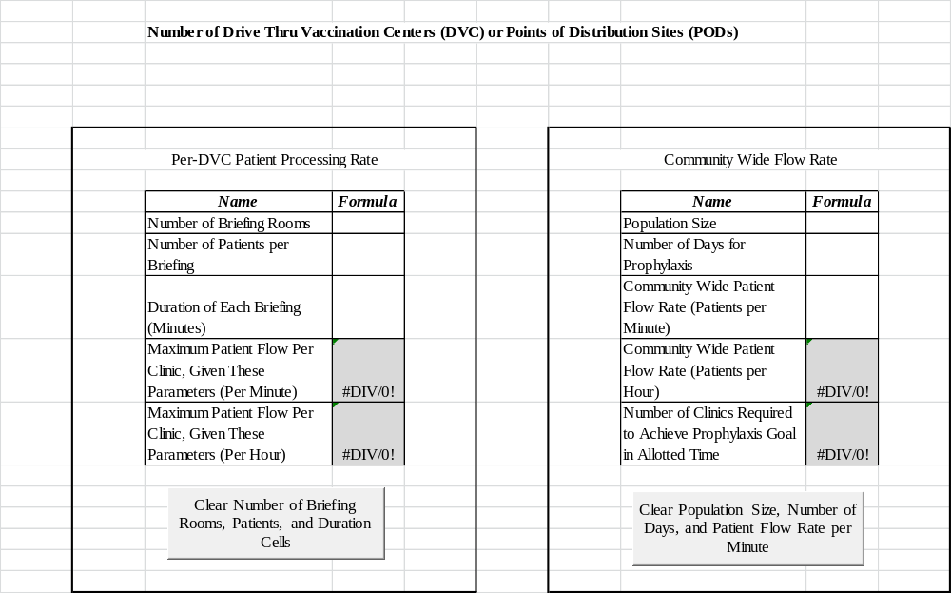
Attachment B: POD Site/Agency Partnerships

Name | Role | Contact Person | Status
Kittitas County Fairgrounds | Use of Facility | 962-7639 | 9.6.13 spoke to Event Center Director. No MOU needed.
Kittitas County Public Works | Traffic control/security | 962-7253
Ellensburg School District | Facility usage and  Transportation support | 925-8000
Cle Elum/Roslyn School District | Facility usage | 649-4850 | MOU signed
ARES/RACES | Coordination of local operators | 933-8218
Hopesource | Transportation assistance | 925-1448
Kittitas County Sheriff | Security and traffic control at all facilities  Search and Rescue Volunteer | 509-962-7525 | CEMP
Grand Meridian Cinema | Parking lot usage for triage in an emergency | 929-5000  925-7757 | Verbal agreement and previous use of location.
Upper Kittitas County Senior Center | Facility Usage (designated emergency shelter) | 674-7530 | MOU Signed
Kittitas County Pharmacies | Assistance distributing medical countermeasures

Staffing Role | Agency/Agencies | Contact Person | Status
Nursing Staff | KVH  MRC | Jim Allen  KCPHD 509-962-7515
Additional Medical Personnel | KVFR | Rich Elliott 509-933-7231
Communications | CWU  KVH  KCSO | Dawn Alford 509-963-5378
Veterinarian and/or animal caretaker | Request Via EOC | Darren Higashiyama 509-201-6013
EH Specialist | Region 7 County Partners | Ray Eickmeyer 509-670-2441 | MOU signed
Administrative Personnel | Region 7 County Partners | Ray Eickmeyer 509-670-2441 | MOU signed
Deputy Registrars | Region 7 County Partners | Ray Eickmeyer 509-670-2441 | MOU signed
Attachment C: Surge Capacity Staffing List

Attachment D: Patient Registration

Client Information:
Last Name |  |  |  | First Name |  |  |  |  |  | Middle Initial
Street Address |  | City |  |  |  | State/Zip Code |  | Race/Ethnicity  (Mark all that apply)  Native American or Alaskan  Asian White  Black or African American  Hispanic/Latino Other:  ______________________________________
Mailing Address (if different) |  | City |  |  |  | State/Zip Code
Phone #1 May we leave a message? Y N |  |  | Phone #2 May we leave a message? Y N
Birthdate (Month/Day/Year) | Sex M F  Other ___________________________ |  |  |  | Marital Status: Single Married Divorced  Separated Widowed Partnered
Primary Language | Do you need an interpreter?  Yes No |  |  |  | Regular Family Doctor or Clinic  None
If client is a minor or dependent, please fill in information about parent or legal guardian:
Last Name |  | First Name |  |  |  |  | Middle Initial |  | Relationship  Mother Father  Foster Parent Grandparent  Legal Guardian  Other:  _______________________________________
Address |  | City |  |  |  |  | State/Zip Code
Phone #1 May we leave a message? Y N |  |  | Phone #2 May we leave a message? Y N
Health Insurance Information (mark all that apply):
No insurance Medicare Medicaid Private Insurance Tricare Other _______________________________________
Does the insurance cover immunizations? Yes No I don’t know
Is there more than one health insurance company? Yes No
Is health insurance provided through an employer? Yes No
PLEASE PRESENT INSURANCE CARDS AT TIME OF APPOINTMENT

Attachment E: Local Mass Clinic Facility Worksheet
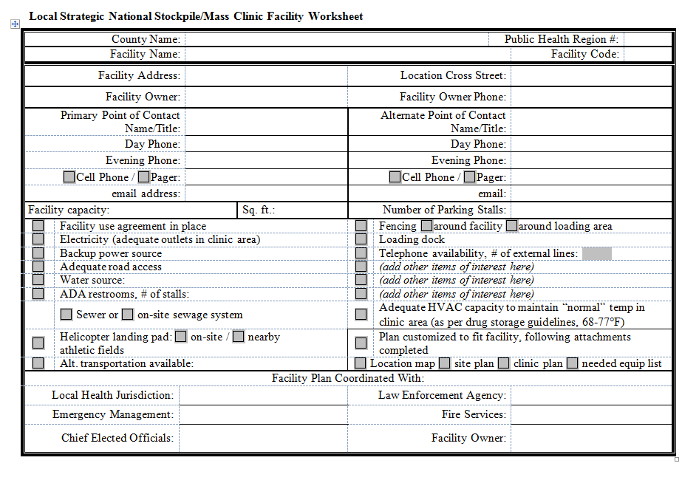

Attachment F:
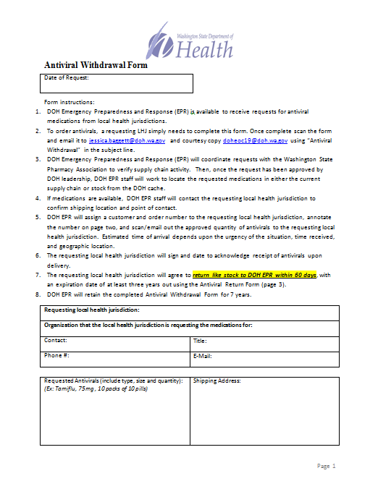

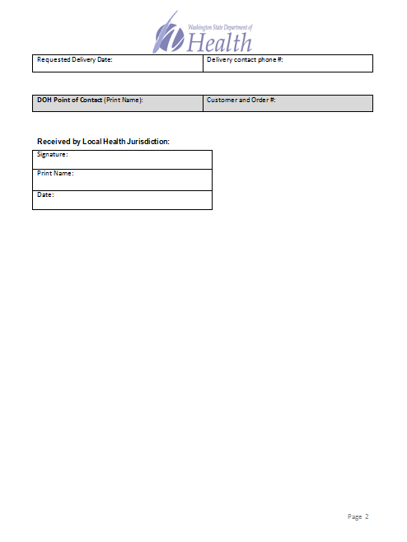
Kittitas County Public Health Department
Pandemic Flu Response
Annex D
Table of Contents

I. INTRODUCTION 60-61
II. PLANNING ASSUMPTIONS 62-63
III. IMPACTS OF A PANDEMIC 63
IV. PHASES OF A PANDEMIC 64
V. CONCEPT OF OPERATIONS 65-66

I. INTRODUCTION:
Pandemics are distinct from seasonal influenza epidemics that happen nearly every year. Seasonal influenza epidemics are caused by influenza viruses that circulate around the world. Over time, people develop some degree of immunity to these viruses and vaccines are developed annually to protect people from serious illness. Pandemic influenza refers to a worldwide epidemic due to a new, dramatically different strain of influenza virus. A pandemic virus strain can spread rapidly from person to person and, if severe, can cause high levels of disease and death around the world.
Pandemic viruses develop in two main ways. First, wild birds are the reservoir for all influenza viruses. Most avian influenza viruses do not infect or cause significant disease in humans. However, new pandemic influenza viruses can arise when avian influenza viruses acquire the ability to infect and cause disease in humans and then spread rapidly from person to person. Secondly, all influenza viruses experience frequent, slight changes to their genetic structure over time.
The development of a novel virus means that most, if not all, people in the world will have never been exposed to the new strain and have no immunity to the disease. It also means that new vaccines must be created and are not likely to be available for months.
Flu pandemics have occurred throughout history. The influenza pandemic of 1918 caused more than 500,000 deaths in the United States and more than 40 million deaths around the world. Subsequent pandemics in 1957-58 and 1968-69 caused far fewer fatalities in the US, but caused significant morbidity and mortality around the world. In 2009, the first US case of H1N1 (swine flu) was diagnosed. The CDC estimates that 43 million to 89 million people had H1N1 between 2009 and 2010 with 8,870 and 18,300 H1N1 related deaths.

Severe influenza versus pandemic influenza:
Pandemic Flu | Seasonal Flu
Rarely happens (three times in 20th century) | Happens annually and usually peaks in January or February
People have little or no immunity because they have no previous exposure to the virus | Usually some immunity built up from previous exposure
Healthy people may be at increased risk for serious complications | Usually only people at high risk, not healthy adults, are at risk of serious complications
Health care providers and hospitals may be overwhelmed | Health care providers and hospitals can usually meet public and patient needs
Vaccine probably would not be available in the early stages of a pandemic | Vaccine available for annual flu season
Effective antivirals may be in limited supply | Adequate supplies of antivirals are usually available
Number of deaths could be high (The U.S. death toll during the 1918 pandemic was approximately 675,000) | Seasonal flu-associated deaths in the United States over 30 years ending in 2007 have ranged from about 3,000 per season to about 49,000 per season.
Symptoms may be more severe | Symptoms include fever, cough, runny nose, and muscle pain
May cause major impact on the general public, such as widespread travel restrictions and school or business closings | Usually causes minor impact on the general public, some schools may close and sick people are encouraged to stay home
Potential for severe impact on domestic and world economy | Manageable impact on domestic and world economy

II. PLANNING ASSUMPTIONS:
A. An influenza pandemic will result in the rapid spread of infection with outbreaks throughout the world. Communities across the state and country may be impacted at the same time.
B. Localities may not be able to rely on timely or effective mutual aid resources, State, or Federal assistance to support local response efforts.
C. An influenza pandemic may occur in waves and last for 12 to 24 months.
D. Residents may be required to stay in their homes for a significant period during an influenza pandemic; thus, residents will need public information, education and tools, so they are prepared to take responsibility for basic needs (food, water, prescription medications, etc.)
E. Antiviral medication will be in extreme short supply. Administration of local supplies of antiviral medication will be prioritized by KCPHD in accordance with CDC and DOH guidelines.
F. A vaccine for the pandemic influenza strain may not likely be available for the first wave following the emergence of the novel virus.
G. The number of ill people requiring care may overwhelm the local healthcare system.
1. KVH and clinics may have to modify their operational structure to respond to high patient volumes.
2. The healthcare system may have to respond to increased demands with a decreased workforce due to illness.
3. Demand for inpatient beds and assist ventilators could increase ten-fold and patients will need to be prioritized for services.
4. There will be tremendous demand for urgent care services.
5. Infection control measures specific to management of influenza patients will need to be developed and implemented in all healthcare facilities.
6. The health system may need to develop alternative care sites to relieve demand on the hospital emergency department.
7. Emergency Medical Service responders will face extremely high call volumes.
8. The number of fatalities may overwhelm the resources of the Kittitas County Coroner’s Office and funeral home.

H. There will likely be significant disruption of public and privately owned critical infrastructure including transportation, commerce, utilities, public safety, and communications.
I. Social distancing strategies aimed at reducing the spread of infection such as closing schools, community centers, and other public gathering points, and canceling public events will likely be implemented during a pandemic.
J. Some persons will be unable or unwilling to comply with isolation directives. For others, social distancing strategies may be less feasible. It will be important to develop and disseminate strategies for infection control appropriate for these environments and populations.
K. Risk communication will be critically important during all phases of planning and implementation of a pandemic influenza response. The general public, healthcare system, response agencies, and elected leaders will need continuous updates on the status of the pandemic outbreak, impacts on critical services, the steps being taken to address the incident, and steps the public can take to protect themselves.

III. IMPACTS OF A PANDEMIC:
Using the CDC’s FluAid 2.0 model, calculations are based on current estimates based on predictions from FluAid 2009.
 | Moderate Pandemic | Severe Pandemic
Total Population in Kittitas County | 41,900 | 41,900
Total Outpatients | 4,815 | 11,200
Total Hospitalizations | 88 | 222
Total Deaths | 28 | 67

IV. PHASES OF A PANDEMIC:
PHASE | DESCRIPTION | MAIN ACTIONS
1 | No circulating animal influenza virus has been reported to have spread to humans. | Plan: Develop, exercise, and revise national influenza pandemic preparedness and response plans.  Monitor & Assess: Collaborate with other agencies to develop a national surveillance system.  Communicate: Communicate real and potential risks of the virus.  Reduce Spread of Disease: Promote healthy behaviors in people for self-protection. Plan for the use of vaccines.  Health Care Continuity: Prepare the health system to scale up.
2 | A circulating animal influenza virus can spread to humans and is considered a threat.
3 | A circulating animal virus has caused disease in some people.
4 | A community-level outbreak has been verified. | Plan: Lead rapid pandemic containment activities to limit the spread of infection.  Monitor & Assess: Increase surveillance and share findings.  Communicate: Promote and communicate recommended interventions to prevent and reduce risk.  Reduce Spread of Disease: Implement rapid pandemic containment operations and other activities.  Health Care Continuity: Activate contingency plans.
5 | The virus has caused community-level outbreaks in two or more countries in one WHO region. | Plan: Coordinate and lead resources to reduce overall impacts of the outbreak.  Monitor & Assess: Continue surveillance to detect ensuing waves.  Communicate: Regularly update the public on any changes to the status of the pandemic.  Reduce Spread of Disease: Implement individual, societal, and pharmaceutical measures.  Health Care Continuity: Implement contingency plans for health systems at all levels.
6 | The virus has caused sustained community-level outbreaks in at least one other country in another WHO region.
POST PEAK PERIOD | Levels of influenza have dropped below peak levels in most countries. | Plan: Plan for additional resources for possible future waves.  Monitor & Assess: Continue surveillance to detect subsequent waves.  Communicate: Regularly update the public on any changes to the status of the pandemic.  Reduce Spread of Disease: Evaluate the effectiveness of the measures used to update guidelines and protocols.  Health Care Continuity: Rest, restock, revise plans, and rebuild.
POST PANDEMIC PERIOD | Levels of influenza have returned to the levels seen for seasonal influenza in most countries. | Plan: Review lessons learned. Share experiences. Replenish resources.  Monitor & Assess: Evaluate the pandemic characteristics for next time.  Communicate: Acknowledge contributions of all communities, communicate the lessons learned.  Reduce Spread of Disease: Evaluate all interventions used.  Health Care Continuity: Evaluate the response of the health system. Share the lessons learned.
V. CONCEPT OF OPERATIONS:
Key response actions by phase as identified by the World Health Organization (WHO), specifically “phase 4” when “community-level outbreaks has been verified.”
A. PHASE 4
1. Disseminate surveillance guidelines to physicians, clinics, and hospitals
2. Track possible cases identified in Kittitas County
3. Establish case definition that aligns with Department of Health and Human Services (HHS), CDC, and DOH.
4. The Public Information Officer (PIO) or designee will develop information related to pandemic influenza activity and forward to media and news sources.
5. KCPHD will develop and disseminate guidelines regarding antivirals based on guidance from CDC and DOH.
6. Develop public information messaging based on expected amounts of vaccine and priority groups.

B. PHASE 5

1. Develop or refine protocol for active surveillance at KVH and other facilities.
2. Provide healthcare sites with instructions about gathering samples from individuals who display symptoms of influenza like illness (ILI) and who are at increased risk for infection according to established guidelines.
3. PIO or designee will disseminate information regarding status of outbreak to all healthcare providers and other facilities at regular intervals.
4. Implement plans for requesting any available drugs through state, federal, or private sources.
5. Monitor adverse reactions to antiviral medications under the guidance of CDC and DOH.
6. Distribute antivirals to priority groups.

C. PHASE 6

1. Screen and/or quarantine international travelers recently arriving in Kittitas County from an area known and/or suspected to be infected, following federal guidelines.
2. Continue to monitor workforce absenteeism within the community through reporting from major employers.
3. Review surveillance data for potential risk factors that either prioritize or deprioritize infected individuals for receiving antivirals and/or vaccine, following state and federal guidelines.
4. Set up a call-in line for healthcare professionals to answer questions relating to the pandemic (unpublished call in line – not for general public).
5. Distribute antivirals to priority groups.
6. Monitor adverse reactions as resources permit.
7. Monitor any cases of resistance to antivirals.
8. Coordinate the processing of mass fatalities with Kittitas County Prosecuting Attorney’s Office and Coroner’s Office.

D. WORKFOURCE MANAGEMENT AND SUPPORT
It is estimated that 30 to 50 percent of the workforce could be impacted by an influenza pandemic. Likewise, an emergency on the scale of an influenza pandemic will have an inevitable psychosocial impact not only on the individuals tasked with directly responding to the outbreak, but the broader population as well. The stresses placed on the workforce by illness-induced absenteeism, the long term nature of the emergency, and the mental health consequences will need to be addressed.

1. Ensure that administrators, managers, and supervisors are familiar with and actively encourage the use of tools and techniques for supporting staff and their families during times of crisis.
2. Educate all staff on Mental Health First Aid.
3. Identify additional recourse that can be available to employees and their families during and after a pandemic.

Kittitas County Public Health Department
Emergency Communication Plan
Annex E
Table of Contents

I. PURPOSE 68

II. SCOPE 68

III. SITUATION OVERVIEW 68

IV. PLANNING ASSUMPTIONS 68-69

V. CONCEPT OF OPERATIONS 69

VIII. ATTACHMENTS

Attachment A Press Release Template and Tips 70-71

Attachment B Common Press Release Templates 72-75

Attachment C Fax Machine Speed Dial Numbers 76-78

Attachment D 24/7 Emergency Contact List 79

Attachment E Regional Satellite Phone Contact List 80

Attachment F Common Media Questions 81-82

Attachment G Recording Hotline Greetings 83-84

Attachment H Emergency Notification Tree 85

I. PURPOSE:
The purpose of communication from KCPHD is to issue information and respond to requests in a timely manner and provide information 24/7 during an emergency. KCPHD will strive to maintain consistency of information distributed and preserve department credibility as well as protect patient confidentiality and be sensitive to issues within the community.
II. SCOPE:
Information may be shared with various audiences including members of the public, community partners, Board of Health members, Board of Health Advisory Committee (BOHAC) members, KCPHD, members of the media, the Washington State Department of Health, and other local health jurisdictions. KCPHD may use various methods of communication, especially during a disruption of technology.
III. SITUATION OVERVIEW:
The department has a designated Public Information Officer (PIO) and a designated back-up PIO. The PIO is responsible for the following during an emergency:
A. Under the direction of the Administrator or Health Officer, the PIO is responsible for all emergency communications.
B. Represent KCPHD at a Joint Information Center (JIC) if one is activated.
C. Coordinate message release with community partners if a joint release is issued.
D. Create all department press releases in emergency situations, even if the Incident Command System (ICS) has been initiated.
E. Message clearance may be expedited to be approved by the Administrator of KCPHD only. Some messages have been preapproved for press releases covering emergencies that routinely happen in Kittitas County (floods, wildfire).
IV. PLANNING ASSUMPTIONS:
During a large scale incident, technology and certain communications may be unavailable. If systems are down, the PIO will post regular updates at the front desk of KCPHD. In addition to physical signage we may use radio stations to broadcast information or HAM radio operators in the county. People with access and functional needs including people with disabilities and residents who are non-native English speakers will need to have access to understandable communication during emergencies. KCPHD will make every attempt to provide information in multiple languages as well as use printed information, including social media graphics from the Washington State Department of Health.
V. CONCEPT OF OPERATIONS:
A. Reports from the public regarding potential health emergencies can be communicated to KCPHD staff during business hours (9am to 5 pm, Monday through Friday) by calling the front desk. After hours, the public should be directed to call 911. KITTCOM (911) has the emergency contact numbers for KCPHD.
B. Reports from key stakeholders such as healthcare providers or other agencies (law enforcement, hospital, emergency services, school personnel, etc.) should have access to the emergency contact number for KCPHD. Communications to KCPHD key stakeholders may also occur during business hours by fax or reporting through the Next Gen electronic medical records system. Staff may also receive SECURES messaging alerts from Washington State DOH.
C. Responding to reports should be completed within 15 minutes of notification. All information that is reported to KCPHD should be reviewed and analyzed as soon as possible. Staff should follow the appropriate department confidentiality processes to assure data are maintained in a secure and confidential manner.
D. Outgoing messaging to public and/or partners will be done via the PIO. The PIO will receive approval from the Administrator and the Health Officer before disseminating information.
E. Information to the public about threats to health and safety will be completed through various mechanisms, for example, via Emergency Management and KITTCOM to utilize reverse 911 or IPAWS in large scale emergency. Public service announcements via local radio stations may also be used in addition to partners’ social media sites.

Attachment A: Press Release Template and Tips

[ON AGENCY LETTERHEAD]

MEDIA RELEASE

Date: Month day, year
Contact: Name, Title, (509) 962-XXXX

[Title – Size 14 font, Bold]
Your title should capture the essence of your news to give media a “handle” for what information will be in the news release.

[Lead sentence – Size 12 font, Times New Roman]
Your lead sentence is critical. You need to succinctly summarize the key elements of your news. Some examples:
- A dead crow found in Snohomish County has tested positive for West Nile Virus (WNV), according to local health officials.
- Now is the time for families in King County to prepare for going back to school, and Public Health - Seattle & King County recommends that the best place to start is by making sure that all of your child's immunizations are up to date.
- Several Walla Walla residents are being treated for possible exposure to rabies after confirmation of the first case of rabies in a cat in Washington State since 1976.
- The Centers for Disease Control and Prevention (CDC) today released new guidelines that advise the use of alcohol-based hand rubs to protect patients in health care settings.

[Second and third paragraph]
Use a quote in your second or third paragraph to support your news and to convey some key messages. The person quoted should be a leader or expert on the topic. Some examples:
- “The chance of human infection is very low – less than one percent of people who are bitten by an infected mosquito will become severely ill,” said M. Ward Hinds, MD, MPH, head of the county’s health department. “We knew that West Nile Virus would arrive in western Washington, it was only a matter of when,” he said.
- "This campaign will help more residents access this model program which offers culturally-sensitive diabetes education and services," said King County Executive Ron Sims.
- "Fortunately in Washington, rabies among both humans and animals is extremely rare, but it is still a very frightening illness to many people," said Dr. Jo Hofmann, Department of Health Communicable Disease Epidemiologist. "But rabies in humans can be prevented if treatment begins soon after exposure."

-more- [indicates more pages follow]

Page 2 of 2
The following paragraphs should provide important supporting information. Your news release should usually be one page, but can be up to two pages. Sometimes a second quote can be used to convey additional key messages or to incorporate a second person’s perspective.
### (indicates end of release)

Attachment B: Common Press Releases

MEDIA RELEASE

Date: Month, Day, Year
Contact: Kasey Knutson, Public Information Officer, 509-962-7515

Poor Air Quality Conditions in Kittitas County

Kittitas County is currently under a [insert air quality status] air quality advisory, which has been issued by the Washington State Department of Ecology (Ecology). Smoke as a result of [name of incident] is affecting the air quality in Kittitas County and the alert issued by Ecology is effective until further notice.

KCPHD wants residents to be aware of current air quality conditions in order to take necessary steps to avoid negative health effects. Air quality information can be accessed at any time via the Washington Air Quality Advisory (WAQA) online https://fortress.wa.gov/ecy/enviwa/. WAQA is a tool that measures the air quality with categories ranging from “good” to “hazardous” air. Additional resources include the following:
- Washington Smoke Blog http://wasmoke.blogspot.com/ contains information about smoke as well as active wildfires.
- Puget Sound Clean Air’s Graphing Tool http://airgraphing.pscleanair.org/ shows real time changes for the station in Ellensburg.
- National Weather Service http://www.weather.gov/ has weather related alerts, including air quality.
- Washington State Department of Health’s Wildfire Smoke page http://www.doh.wa.gov/CommunityandEnvironment/AirQuality/SmokeFromFires/WildfireSmoke explains the harm of wildfire smoke.

“Outdoor activities should take place when we have “good” air. When air quality changes to “moderate” or worse, we recommend people start making changes, including moving indoors,” asserts Kittitas County Health Officer, Dr. Mark Larson.

Attached is the “Air Pollution and School Activities” table for specific recommendations based on air quality conditions. For more information about health concerns relating to air quality or informational resources, please contact KCPHD at (509)-962-7515.

MEDIA RELEASE

Date: Month, Day, Year
Contact: Kasey Knutson, Public Information Officer, 509-962-7515

Flood Waters Can Be Harmful to Health

With recent flooding in Kittitas County, the Kittitas County Public Health Department (KCPHD) is reminding residents that flood water is unsafe. Flood water can create risks including, exposure to infectious diseases, chemical hazards, and injuries, according to the Centers for Disease Control and Prevention (CDC).

During clean up after floods; wear rubber boots, rubber gloves, and goggles during cleaning the affected area. After completing cleanup, wash all clothes worn in hot water and detergent as well as washing your hands with soap and warm water.

If your well head was covered by flood waters, KCPHD recommends NOT consuming water from the well until it has been tested and proven to be absent of bacteria. Until you receive test results that show the water is free of bacteria, you should use bottled water or water that has not been exposed to flood waters. If bottled water is not available, you should boil water before using for drinking, preparing food, washing dishes, brushing teeth, et cetera. Boil water for at least one minute and cool completely before use.

Water testing bottles are available at KCPHD from 9am to 5pm for pick up, Monday through Friday. Water samples should be taken from your home on the same morning you intend to drop the sample off at KCPHD. Drop off for samples is between 9 and 11 and the courier picks up water, daily, from KCPHD at 11am.

Disinfection of your well is necessary if test results show bacterial contamination. For instructions on disinfecting wells, please visit the Kittitas County Public Health Department’s website at www.co.kittitas.wa.us/health/ for a fact sheet on the disinfection of private water wells.

For questions about boiling water, disinfecting wells, or water testing, please contact the Kittitas County Public Health Department at 509-962-7515.

MEDIA RELEASE

Date: Month, day, year
Contact: Kasey Knutson, Public Information Officer, 509-962-7515

Wildland Fire Recovery: Returning Home after [Name of Fire Incident]

The Kittitas County Public Health Department (KCPHD) is urging everyone to be aware of potential dangers and to take safety measures when returning to their homes after [name of fire incident]. Please be cautious that [name of the fire incident] may have created hazards in and around your home.

To prevent injury when entering your home, be sure to wear Personal Protective Equipment (PPE). Protective equipment may include sturdy shoes to protect from glass or sharp objects, longs pants and shirt, hard hat, and a mask to prevent inhalation of dust and ash.

Be advised:
- Wear protective clothing in order to avoid skin contact and inhalation of ash and other materials.
- Well-fitting dust masks (masks rated N-95 or P-100) are effective at blocking the particles from ash during cleanup.
- It is not uncommon that animals may take refuge in or near your home during the fire. If you find animals in your home allow them to return to their natural habitat, or contact proper authorities for removal.
- If you are in need of disposal or burial of any domesticated animals or livestock, be sure every part of the carcass is covered by at least three feet of soil; at a location at least 100 feet away from any well, spring, stream, or other surface waters; not in a low-lying area subject to seasonal flooding or within a 100-year flood plain; and not in a location likely to contaminate ground water.
- According to the Centers for Disease Control and Prevention (CDC) you should not consume any food that looks or smells bad. Throw away exposed perishable food that may be questionable, including canned goods and refrigerated items.
- For those who have an open or closed wound and are returning to the burn area and who have not had a documented dose of tetanus vaccine within the past ten years should get a tetanus shot before returning home.

For more information on returning home after a disaster and how to stay safe, visit the Centers for Disease Control at http://emergency.cdc.gov/disasters/wildfires/afterfire.asp. Please contact the Kittitas County Public Health Department if you have concerns about disease and injury prevention relating to returning home at 509-962-7515.

MEDIA RELEASE

Date: Month, day, year
Contact: Kasey Knutson, Public Information Officer, 509-962-7515

Shelter in Place Issued for [location]

A shelter in place alert has been ordered for [location] by [agency]. Hazardous materials have been released and all residents or anyone in the area should remain indoors, effective immediately. [Brief details of the incident and include symptoms of exposure]

Sheltering in place means:
- Go inside.
- Close all windows and doors.
- Turn off ventilation systems – turn of all air conditioners, fans, etc.
- Go into a room with the fewest doors and windows.
- Stay in the room until told by the authorities it is safe to come out.

Further information will be provided by [agency] at [website] Phone lines should be left open for emergency responders.

For anyone outside of the area, please avoid driving near [location]. Please give emergency personnel the right of way.

According to the Washington State Department of Health (DOH), if you have symptoms of exposure, call 9-1-1 immediately and follow their instructions. If you were outside before taking shelter and think you may have been exposed to a chemical agent, there are several things you can do. If you are in a sealed shelter, take off at least your outer clothes, put them in a plastic bag and seal the bag. If water is available, wash or take a cool to warm (not hot) shower, using lots of soap and water. Do not put the soap in your eyes, just lots of water. If you leave the area, tell emergency responders or medical staff at your destination you may have been exposed. Tell the emergency responders about the sealed bag so that they can arrange for its safe removal after the emergency.

For more information go to [give location of available information that IS NOT connected to a phone line].
###

Attachment C: List of Fax Machine Speed Dial Numbers
To Send a Fax: (Must place 1 page in fax)
Press Search/Speed Dial and “#”; enter 3-digit speed dial number. Press start.

Health Care Providers
Kittitas Valley Healthcare Family Medicine 5099338741
Family Health Care 5099622003
Community Health of Central Washington 5099621408
Kittitas Valley Healthcare Family Medicine Cle Elum 5096745034
Ellensburg Pediatrics 5099625438
Emergency Medical Service Coordinator 5096742947
Kittitas Valley Healthcare Internal Medicine 5099257604
Kittitas Valley Healthcare General Surgery 5099256948
OB/GYN of Ellensburg (Dr. Sand) 5099258468
Student Medical & Counseling Clinic 5099631886
Kittitas Valley Healthcare Emergency Department 5099337510
Kittitas Valley Healthcare CEO 5099258485
Kittitas Valley Healthcare Laboratory Services 509933-8795
Kittitas Valley Healthcare Urgent Care – Cle Elum 5096747794
Planned Parenthood 5092483664
Kittitas Valley Healthcare Women’s Health 5099338722
Coroner’s Office 5099338224

Region 7
Chelan Douglas Health District 5098666449
Okanogan County Public Health 5094227152
Grant Health District 5097666519

Kittitas Co Media
North Kittitas County Tribune 5096745571
Daily Record 5099726920
KCWU 88.1 The ‘Burg 5099631688
Central Washington University the Observer 5099631027
Non Local Media
La Grand 96.9 Spanish Radio 5094520541
KAPP-ABC Television 5094533623
KIMA Television News 5092481218
Yakima Herald 5095777767
KNDO 5092252330
KNWR 5093366577
KNDA 5098542223
KCYU FOX 41 5094579903

Emergency Response
Kittitas County Board of County Commissioners 5099627679
Cle Elum Fire Department 5096745771
Cle Elum/Roslyn Police Department 5096742918
Central Washington University Police 5099632750
Ellensburg Police 5099627281
Emergency Medical Service Coordinator 5096742947
Fire District #1 5099642022
Fire District #2 5099337240
Fire District #51 4254346355
Regional Epidemiologist 5098866449
Prosecutor Office 5099627022
KITTCOM911 5099258540
Fire Marshall 5099627682
Kittitas County Sheriff Public Safety Building 5099627599
City of Kittitas Police & Emergency Services 5099680223
Red Cross 5099259156
Washington State Patrol 5096654007
Fire District #3 5096560121
Fire District #7 5096747263
Kittitas Valley Fire/Rescue – Deputy Chief Elliott 5099337245
Kittitas Valley Community Hospital District #1 5099627351
Comprehensive Healthcare - Mental Health 5099251277

Pharmacies
Bi-mart Pharmacy 5099625322
Downtown Pharmacy 5099251545
Fred Meyer Pharmacy 5099620527
Rite Aid Pharmacy 5099256063
Safeway Pharmacy 5099256044
Super One Pharmacy 5099627785
Safeway Cle-Elum 5098523010

Veterinarians
Critter Care Animal Clinic 8316261698
Ellensburg Animal Hospital 5099257714
Mt Stuart Animal 8002555067
Valley Veterinary 5099256148

Schools
Ellensburg School District 5099258025
Ellensburg High School 5099258305
Lincoln Elementary 5099258056
Morgan Middle School 5099258200
Mount Stuart Elementary 5099258407
Valley View Elementary 5099258134
Kittitas School Dist 5099684730
Kittitas Elementary School (K-5) 5099683630
Kittitas Secondary School (6-12) 5099683370
Thorp School District 5099642313
Cle Elum – Roslyn School District 5096492404
Cle Elum HS 5096493563
Walter Strom Middle School - Cle Elum 5096493634
Cle Elum-Roslyn Elementary School 5096492074
Damman School District 5099252591
Easton School District 5096562585

Long Term Care Facilities
Hearthstone 5099251144
Prestige Post-Acute and Rehab Center 5099254173
Pacifica Senior Living 5099251230

Attachment D: 24/7 Emergency Contacts List

Kittitas County Emergency Contacts List
Kittitas County Information Services | (509) 962-7510 | Jim Goeben
Central Washington University (CWU) Police | (509) 963-2959
CWU Public Affairs | (509) 963-1384 | Linda Schactler
Kittitas Valley Healthcare Public Affairs | (509) 933-7593
Kittitas County Sheriff/Emergency Management | (509) 933-8206 | Darren Higashiyama
Kittitas County Emergency Operation Center | (509) 962-7678
Kittitas County Emergency Medical Services | (509) 962-7683 | Cheryl Burrows
Kittitas County Fire | (509) 962-7274 | John Sinclair
Kittitas County Fire District #7 | (509) 649-3381 | Richelle Risdon
Kittitas County Red Cross | (509) 929-0331 | Martha Read
Central Washington Comprehensive Mental Health | (509) 925-9861 | Dr. Harry Kramer
Ellensburg Police Department | (509) 962-7280 | Ken Wade
ARES/RACES | (509) 962-3820 | Gloria Sharp
24/7 Washington State Department of Health Duty Officer | (360-888-0838 | DOH Duty Officer
Washington State Department of Health Risk Communications | (360) 236-4070 | Laura Blaske
WA DOH Epidemiology and surveillance | (206) 418-5518 | Mike Boysun
Public Health Laboratory 24/7 Emergency Telephone Service | (206)418-5500
Drinking Water After-Hours Emergency Hotline | 1-877-481-4901
Valley Lab | 1-877-242-3999
Last updated 7/31/2018

Attachment E: Regional Satellite Phone Numbers

Regional Satellite Phone Numbers
Kittitas County Emergency Management | (254) 241-5879 | Ellensburg
Region 7 Public Health
Chelan-Douglas Health District | (254) 204-0589 | Wenatchee
Chelan-Douglas Health District-fixed | (254) 377-2969 | Wenatchee
Grant County Health District | (254) 204-0620 | Moses Lake
Grant County Health District-fixed | (254) 377-7250 | Moses Lake
Okanogan County Public Health | (254) 204-0626 | Okanogan
Okanogan County Public Health-fixed | (254) 377-5227 | Okanogan
Region 7 Hospitals
Kittitas Valley Healthcare | (254) 387-9399 | Ellensburg
Okanogan Douglas Hospital | (254) 387-3385 | Brewster
Quincy Valley Med | (254) 387-5984 | Quincy
Samaritan Healthcare | (254) 387-5985 | Moses Lake
Wenatchee Valley Med Center | (254) 387-3383 | Wenatchee
Cascade Medical Center | (254) 387-3388 | Leavenworth
Coulee Comm. Hospital | (254) 387-5783 | Grand Coulee
Central Washington Hospital | (254) 387-5784 | Wenatchee
Columbia Basin Hospital | (254) 387-7599 | Ephrata
Lake Chelan Community Hospital | (254) 387-3389 | Chelan
Mid Valley Hospital | (254) 387-5781 | Omak
North Valley Hospital | (254) 387-5780 | Tonasket
Moses Lake Community Health | (863) 200-5297 | Moses Lake
Last updated 12/9/10

Attachment F: Common Media Questions
(Reprinted from: Covello, V.T., Keeping Your Head In A Crisis: Responding To Communication Challenges Posed By Bio-terrorism And Emerging Infectious Diseases. Association of State and Territorial Health Officers (ASTHO), 2003 in press)
Journalists are likely to ask six questions in a crisis (who, what, where, when, why, how) that relate to three broad topics: (1) what happened; (2) what caused it to happen; (3) what it means. Specific questions include:
          - What is your name and title?
          - What are you job responsibilities?
          - What are your qualifications?
          - Can you tell us what happened?
          - When did it happen?
          - Where did it happen?
          - Who was harmed?
          - How many people were harmed?
          - Are those that were harmed getting help?
          - How certain are you about this information?
          - How are those who were harmed getting help?
          - Is the situation under control?
          - How certain are you that the situation is under control?
          - Is there any immediate danger?
          - What is being done in response to what happened?
          - Who is in charge?
          - What can we expect next?
          - What are you advising people to do?
          - How long will it be before the situation returns to normal?
          - What help has been requested or offered from others?
          - What responses have you received?
          - Can you be specific about the types of harm that occurred?
          - What are the names of those that were harmed?
          - Can we talk to them?
          - How much damage occurred?
          - What other damage may have occurred?
          - How certain are you about damages?
          - How much damage do you expect?
          - What are you doing now?
          - Who else is involved in the response?
          - Why did this happen?
          - What was the cause?
          - Did you have any forewarning that this might happen?
          - Why wasn't this prevented from happening?
          - What else can go wrong?
          - If you are not sure of the cause, what is your best guess?
          - Who caused this to happen?
          - Who is to blame?
          - Could this have been avoided?
          - Do you think those involved handled the situation well enough?
          - When did your response to this begin?
          - When were you notified that something had happened?
          - Who is conducting the investigation?
          - What are you going to do after the investigation?
          - What have you found out so far?
          - Why was more not done to prevent this from happening?
          - What is your personal opinion?
          - What are you telling your own family?
          - Are all those involved in agreement?
          - Are people over reacting?
          - Which laws are applicable?
          - Has anyone broken the law?
          - How certain are you about whether laws have been broken?
          - Has anyone made mistakes?
          - How certain are you that mistakes have not been made?
          - Have you told us everything you know?
          - What are you not telling us?
          - What effects will this have on the people involved?
          - What precautionary measures were taken?
          - Do you accept responsibility for what happened?
          - Has this ever happened before?
          - Can this happen elsewhere?
          - What is the worst case scenario?
          - What lessons were learned?
          - Were those lessons implemented?
          - What can be done to prevent this from happening again?
          - What would you like to say to those that have been harmed and to their families?
          - Is there any continuing the danger?
          - Are people out of danger? Are people safe?
          - Will there be inconvenience to employees or to the public?
          - How much will all this cost?
          - Are you able and willing to pay the costs?
          - Who else will pay the costs?
          - When will we find out more?
          - What steps need to be taken to avoid a similar event?
          - Have these steps already been taken? If not, why not?
          - What does this all mean?

Attachment G: Recording Hotline Greetings

The contact at Consolidated Communications for additional phone tree assistance is Jackie Bostick. Phone, 962-0318. Email, jbostick@fairpoint.com. In additional to the phone numbers below, 933-8245 can be used for a hotline, with password 84250.

Dial 962-0300, press *, enter 9627515, password is 7515. Select 3 to change the greeting, then 1 to change the greeting, and 2 to record a new mailbox greeting.
Hello, you have reached the Kittitas County Public Health Department.
If you have questions A, B, or C press one now. (Transfers to 9627589)
For all other public health questions press 2 now or stay on the line. [Pause up to four seconds, then press #] (Rings through to 9627515)

Dial 962-0300, press *, enter 9627589, password is 7589. Select 3 to change the greeting, then 1 to change the greeting, and 2 to record a new mailbox greeting.
Please listen to the following three options before making your selections:
For information about A, press one. (Transfers to 5559621)
For information about B, press two. (Transfers to 5559622)
For information about C, press three. [Pause up to four seconds, then press #] (Transfers to 5559623)

Dial 962-0300, press *, enter 5559621, password is 1269. Select 4 for personal options, then 3 for greetings, then 1 to change the greeting, then 2 to record the greeting.
Topic A
During business hours, you will have the opportunity to talk to a staff member at the end of this call, but please listen to this message first as it may answer your questions.
Message here.
If you would like to speak to a front desk staff member, please press 0 now. [Pause up to four seconds, then press #] (Transfers directly to 9627515 without initial message again)

Dial 962-0300, press *, enter 5559622, password is 2269. Select 4 for personal options, then 3 for greetings, then 1 to change the greeting, then 2 to record the greeting.
Topic B
During business hours, you will have the opportunity to talk to a staff member at the end of this call, but please listen to this message first as it may answer your questions.
Message here.
If you would like to speak to a front desk staff member, please press 0 now. [Pause up to four seconds, then press #] (Transfers directly to 9627515 without initial message again)

Dial 962-0300, press *, enter 5559623, password is 3269. Select 4 for personal options, then 3 for greetings, then 1 to change the greeting, then 2 to record the greeting.
Topic C
During business hours, you will have the opportunity to talk to a staff member at the end of this call, but please listen to this message first as it may answer your questions.
Message here.
If you would like to speak to a front desk staff member, please press 0 now. [Pause up to four seconds, then press #] (Transfers directly to 9627515 without initial message again)

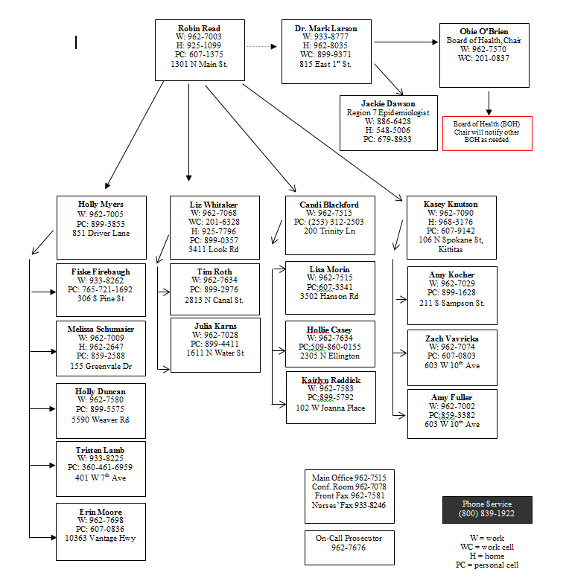
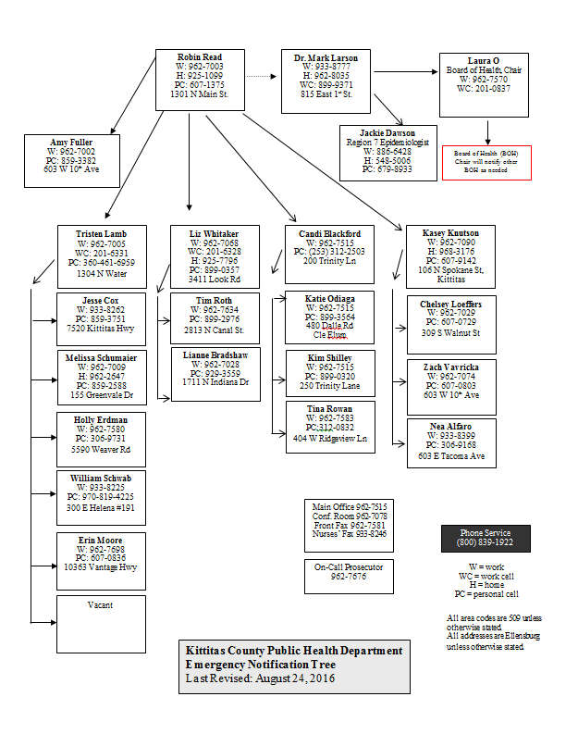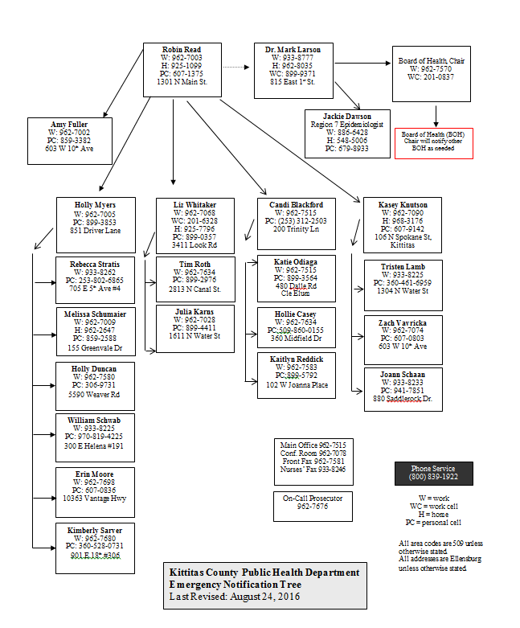

Kittitas County Public Health Department
Shelter/Mass Care Plan
Annex F
Table of Contents

I. PURPOSE 87
II. SCOPE 87
III. CONCEPT OF OPERATIONS 87
Attachment A Shelter-Tool Form 88

I. PURPOSE:
KCPHD will be responsible for assessing conditions of emergency shelter facilities during disasters, which include shelters for displaced individuals or for emergency workers responding to the incident in order to protect the occupants of the shelter.
II. SCOPE:
Shelters include temporary housing for individuals who are displaced from their homes due to an emergency or the temporary housing of individuals responding to the emergency that operate within the local jurisdiction.
III. CONCEPT OF OPERATIONS:
KCPHD will ensure shelters meet appropriate health and safety standards. Staff will utilize the Centers for Disease Control and Prevention (CDC) standard evaluation form (Attached) to identify priority health and safety issues along with recommendations for improvements if needed.

State Logo | ENVIRONMENTAL HEALTH ASSESSMENT FORM FOR SHELTERS  For Rapid Assessment of Shelter Conditions during Disasters |  |  |  |  |  |  |  | 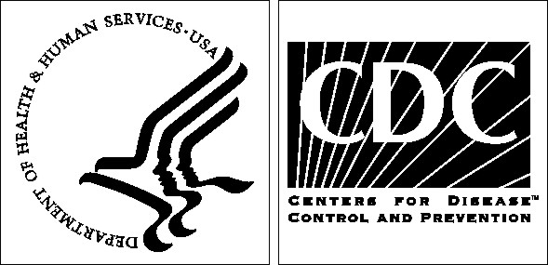
I. ASSESSING AGENCY DATA
¹Agency /Organization Name ___________________________________________________________________ |  |  |  |  |  | ⁹⁰Immediate Needs Identified: Yes No
²Assessor Name/Title ___________________________________________________________________________________________________________________
³Phone __ __ __ - __ __ __ - __ __ __ __ ⁴Email or Other Contact ____________________________________________________________________
II. FACILITY TYPE, NAME AND CENSUS DATA
⁵Shelter Type Community/Recovery Special Needs Other _______________________ ⁶ARC Facility Yes No Unk/NA ⁷ARC Code ________
⁸Date Shelter Opened __ __ /__ __/__ __ (mm/dd/yr) ⁹Date Assessed __ __ /__ __/__ __ (mm/dd/yr) ¹⁰Time Assessed __ __ : __ __ am pm
¹¹Reason for Assessment Preoperational Initial Routine Other __________________________________________________________________
¹²Location Name and Description ___________________________________________________________________________________________________________
¹³Street Address ________________________________________________________________________________________________________________________
¹⁴City / County ____________________________________ ¹⁵State __ __ ¹⁶Zip Code __ __ __ __ __ ¹⁷Latitude/Longitude ________________/_______________
¹⁸Facility Contact / Title _______________________________________________ ¹⁹Facility Type School Arena/Convention center Other______________
²⁰Phone __ __ __ - __ __ __ - __ __ __ __ ²¹Fax __ __ __ - __ __ __ - __ __ __ __ ²²E-mail or Other Contact _______________________________
²³Current Census _____________ ²⁴Estimated Capacity ______________ ²⁵Number of Residents ____________ ²⁶Number of Staff / Volunteers __________
III. FACILITY |  |  |  | VIII. SOLID WASTE GENERATED
²⁷Structural damage |  |  | Yes No Unk/NA | ⁶⁶Adequate number of collection receptacles |  |  |  | Yes No Unk/NA
²⁸Security / law enforcement available |  |  | Yes No Unk/NA | ⁶⁷Appropriate separation |  |  |  | Yes No Unk/NA
²⁹Water system operational |  |  | Yes No Unk/NA | ⁶⁸Appropriate disposal |  |  |  | Yes No Unk/NA
³⁰Hot water available |  |  | Yes No Unk/NA | ⁶⁹Appropriate storage |  |  |  | Yes No Unk/NA
³¹HVAC system operational |  |  | Yes No Unk/NA | ⁷⁰Timely removal |  |  |  | Yes No Unk/NA
³²Adequate ventilation |  |  | Yes No Unk/NA | ⁷¹Types | Solid Hazardous Medical Unk/NA
³³Adequate space per person |  |  | Yes No Unk/NA | IX. CHILDCARE AREA
³⁴Free of injury /occupational hazards |  |  | Yes No Unk/NA | ⁷²Clean diaper-changing facilities |  |  |  | Yes No Unk/NA
³⁵Free of pest / vector issues |  |  | Yes No Unk/NA | ⁷³Hand-washing facilities available |  |  |  | Yes No Unk/NA
³⁶Acceptable level of cleanliness |  |  | Yes No Unk/NA | ⁷⁴Adequate toy hygiene |  |  |  | Yes No Unk/NA
³⁷Electrical grid system operational |  |  | Yes No Unk/NA | ⁷⁵Safe toys |  |  |  | Yes No Unk/NA
³⁸Generator in use, ³⁹ If yes, Type__________ |  |  | Yes No Unk/NA | ⁷⁶Clean food/bottle preparation area |  |  |  | Yes No Unk/NA
⁴⁰Indoor temperature _________ ºF |  |  | Yes No Unk/NA | ⁷⁷Adequate child/caregiver ratio |  |  |  | Yes No Unk/NA
IV. FOOD |  |  |  | ⁷⁸Acceptable level of cleanliness |  |  |  | Yes No Unk/NA
⁴¹Preparation on site |  |  | Yes No Unk/NA | X. SLEEPING AREA
⁴²Served on site |  |  | Yes No Unk/NA | ⁷⁹Adequate number of cots/beds/mats |  |  |  | Yes No Unk/NA
⁴³Safe food source |  |  | Yes No Unk/NA | ⁸⁰Adequate supply of bedding |  |  |  | Yes No Unk/NA
⁴⁴Adequate supply |  |  | Yes No Unk/NA | ⁸¹Bedding changed regularly |  |  |  | Yes No Unk/NA
⁴⁵Appropriate storage |  |  | Yes No Unk/NA | ⁸²Adequate spacing |  |  |  | Yes No Unk/NA
⁴⁶Appropriate temperatures |  |  | Yes No Unk/NA | ⁸³Acceptable level of cleanliness |  |  |  | Yes No Unk/NA
⁴⁷Hand-washing facilities available |  |  | Yes No Unk/NA | XI. COMPANION ANIMALS
⁴⁸Safe food handling |  |  | Yes No Unk/NA | ⁸⁴Companion animals present |  |  |  | Yes No Unk/NA
⁴⁹Dishwashing facilities available |  |  | Yes No Unk/NA | ⁸⁵Animal care available |  |  |  | Yes No Unk/NA
⁵⁰Clean kitchen area |  |  | Yes No Unk/NA | ⁸⁶Designated animal area |  |  |  | Yes No Unk/NA
V. DRINKING WATER AND ICE |  |  |  | ⁸⁷Acceptable level of cleanliness |  |  | Yes No Unk/NA
⁵¹Adequate water supply |  |  | Yes No Unk/NA | XII. OTHER CONSIDERATIONS
⁵²Adequate ice supply |  |  | Yes No Unk/NA | ⁸⁸Handicap accessibility |  |  |  | Yes No Unk/NA
⁵³Safe water source |  |  | Yes No Unk/NA | ⁸⁹Designated smoking areas |  |  | Yes No Unk/NA
⁵⁴Safe ice source |  |  | Yes No Unk/NA | XIII. COMMENTS (List Critical Needs on Immediate Needs Sheet)
VI. HEALTH / MEDICAL |  |  |  | __________________________________________________________________
⁵⁵Reported outbreaks, unusual illness / injuries |  |  | Yes No Unk/NA | __________________________________________________________________
⁵⁶Medical care services on site |  |  | Yes No Unk/NA | __________________________________________________________________
⁵⁷Counseling services available |  |  | Yes No Unk/NA | __________________________________________________________________
VII. SANITATION |  |  |  | __________________________________________________________________
⁵⁸Adequate laundry services |  |  | Yes No Unk/NA | __________________________________________________________________
⁵⁹Adequate number of toilets |  |  | Yes No Unk/NA | __________________________________________________________________
⁶⁰Adequate number of showers |  |  | Yes No Unk/NA | __________________________________________________________________
⁶¹Adequate number of hand-washing stations |  |  | Yes No Unk/NA | __________________________________________________________________
⁶²Hand-washing supplies available |  |  | Yes No Unk/NA | __________________________________________________________________
⁶³Toilet supplies available |  |  | Yes No Unk/NA | __________________________________________________________________
⁶⁴Acceptable level of cleanliness |  |  | Yes No Unk/NA | __________________________________________________________________
⁶⁵Sewage system type |  | Community On site Portable Unk/NA

Kittitas County Public Health Department
Continuity of Operations Plan (COOP)
Annex G
Table of Contents

I. PURPOSE 90

II. SITUATION OVERVIEW 90

IV. PLANNING ASSUMPTIONS 90

V. CONCEPT OF OPERATIONS 91

VI. SUCCESSION PLAN 91-93

VIII. ATTACHMENTS 94-96
Attachment A Organizational Chart 94
Attachment B Essential Services 95-96

I. PURPOSE:
The purpose of the continuity of operations plan is to identify, address, and ensure essential functions of services from KCPHD are maintained during an emergency or extended incident. Critical operations during any incident must be maintained and are services that are required by law. (Essential Services are attached)
II. SITUATION OVERVIEW:
KCPHD operates under the direction of the Kittitas County Board of County Commissioners and in emergencies under the Kittitas County Emergency Management Office (KCSO). The KCPHD Administrator, Health Officer, and Board of Health have the authority to determine, which services are discretional and may be terminated or temporarily stopped during an emergency.
If KCPHD is required to move as a result of an emergency or incident, the location will be determined with Emergency Management recommendations and Board of County Commissioner approval. Essential Functions that will be provided by the Kittitas County Public Health Department in the event of an emergency or displacement from its regular location are: Food Safety, Water Mitigation, Drinking Water, On-Site Septic, Vector Borne Disease/Zoonotic, Pools and Spas, Solid Waste, Camps & Parks, and Schools, Vital Records and Immunizations.
Because of limited capabilities and capacity, non-essential staff may not need to report for work until normal operations and location are re-established.

IV. PLANNING ASSUMPTIONS:
During a large scale incident, technology, electricity, and certain communications may be unavailable. If systems are down, the Public Information Officer will post regular updates at the front desk of KCPHD. In addition to physical signage we may use radio stations to broadcast information or HAM radio operators in the county. People with access and functional needs including people with disabilities and residents who are non-native English speakers will need to have access to understandable communication during emergencies. KCPHD will make every attempt to provide information in multiple languages as well as use printed information, including social media graphics from the Washington State Department of Health.
KCPHD would need to provide a source of power to keep vaccines refrigerated in the event of a power outage, or if vaccines needed to move offsite because of an emergency incident. If KCPHD does not have power or equipment failure, vaccine will be stored at Kittitas Valley Healthcare via an interlocal agreement.

V. CONCEPT OF OPERATIONS:
KCPHD will be notified of an alternate work location via EM or BOCC
In the event that electronic capabilities are unavailable, hard copies of records will be taken and uploaded at a later date when electronic capabilities have been restored. Hard copies are already kept and stored for essential services provided by the Kittitas County Public Health Department.
If electronic capabilities are available either by VPN or through regular means, financial transactions will be conducted as usual. If electronic capabilities are not available, cash and check may be accepted, and hand written receipts will be issued.
Vaccines can be transported via portable plug-in refrigeration units that can be powered by an external battery.
To-go kits or “Go Box” items will consist of necessary paperwork to conduct essential services, pens, pencils, highlighters, rubber bands, rubber gloves, bungee cords, stapler, post-it notes, tape, binder clips, printer paper, power inverter, size D batteries, rubber stamp, and phone and message books. They are located at the front desk area of the KCPHD office.
VI. SUCCESION PLAN:
In the absence of the KCPHD Administrator, delegation of authority within KCPHD has been determined below specific to function and assigned personnel in order to continue the performance of critical functions. Ultimate delegation of authority resides with the Board of County Commissioners (BOCC). If BOCC is absent, then delegation of authority would follow the Kittitas County plan via Emergency Management.

Function | Staff Responsible
Communication
- Serve as the organization’s principal leader, representative, and spokesperson to the greater community. | Health Officer with support from:  - Assessment Coordinator I  - CHS Supervisor  - EH Supervisor  - HP Manager
- Ensure that key funders/contractors are aware of the change in KCPHD lead contract staff as appropriate. | CHS Supervisor  EH Supervisor  HP Manager
- Ensure that accurate information relating to the condition of the agency is communicated to department staff. | Health Officer with support from:  - Assessment Coordinator I  - CHS Supervisor  - EH Supervisor  - HP Manager
- Ensure communication between Board of Health and the Management Team. | Health Officer with support from:  - CHS Supervisor  - EH Supervisor  - HP Manager
Support the Board of Health
- Assist with preparation of Board of Health agendas, develop executive reports, and facilitate Board of Health meetings. | Health Officer with support from:  - Administrative Assistant II  - Assessment Coordinator I  - CHS Supervisor  - EH Supervisor  - HP Manager
- Address Board issues related to clarity of role, governance, bylaws, policies, board structure and membership. | CHS Supervisor  EH Supervisor  HP Manager
- Assist with recruitment and orientation of new Board members. | CHS Supervisor  EH Supervisor  HP Manager
Management Team Support
- Convene and lead the management team. | Health Officer with support from:  - CHS Supervisor  - EH Supervisor  - HP Manager
- Ensure fiscal oversight | Fiscal Analyst
- Maintain accountability for financial performance of department. | Fiscal Analyst with support from:  - CHS Supervisor  - EH Supervisor  - HP Manager  - Administrative Assistant II
Operations
- Ensure administrative level support of the overall management of the department. | Chair of the Board of Health
- Ensure continuity of service operations | CHS Supervisor  EH Supervisor  HP Manager  Administrative Assistant II
- Ensure ongoing fiscal integrity and operations | Fiscal Analyst
- Authorize major expenditures | Fiscal Analyst
- Ensure timely billing/collections | Fiscal Analyst
- Ensure human resources compliance | HR Director with support from:  - CHS Supervisor  - EH Supervisor  - HP Manager  - Administrative Assistant II
- Prepare, submit and present department program information to the BOCC Agenda as required. | CHS Supervisor  EH Supervisor  HP Manager  - With support from Administrative Assistant II
- Ensure contract compliance
- Processing new contracts through Kittitas County Prosecutor, Auditor and BOH/BOCC Systems including presentations at BOCC Agenda and BOH meetings. | Administrative Assistant II
- Fiscal reporting | Fiscal Analyst
- Program Tracking/Reporting | Assessment Coordinator I  CHS Supervisor  EH Supervisor  HP Manager

Attachment A: KCPHD Organizational Chart
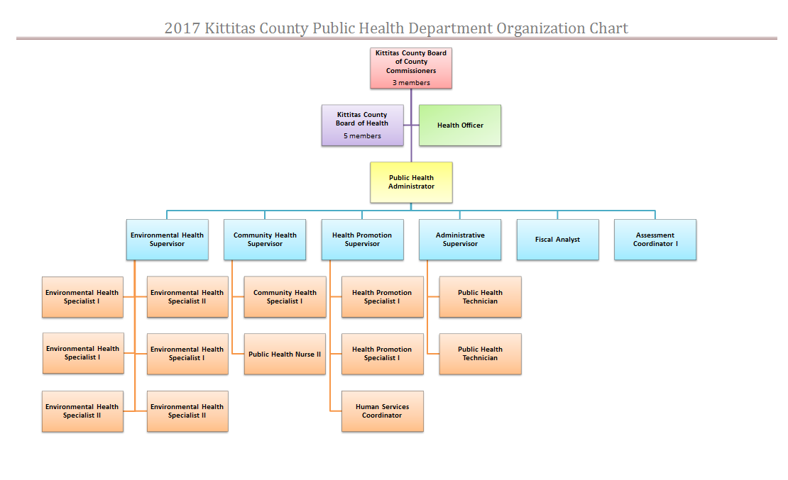

Attachment B: Essential Services

Identified Essential Services to Sustain LHJ Mission and Operations
DESCRIPTION | FOUNDATIONAL/ESSENTIAL | REQUIRED BY LAW?
Birth certificates are available for births in Washington after July 1907. Death certificates are available for deaths that were electronically filed after August 2013. | Program | RCW 70.58.020  WAC  246-490-010

DESCRIPTION | FOUNDATIONAL/ESSENTIAL | REQUIRED BY LAW?
The communicable disease program is responsible for preventing and investigating outbreaks and controlling the spread of communicable diseases in the community. | Capability/  Program  ES#1, 2, 3, 4, 5, 6, 7 | RCW 70.05.070  WAC  246-100-036
The tuberculosis program provides referrals for tuberculosis treatment and monitoring of tuberculosis cases. | Program  ES#1, 2, 7 | 70.28.005  70.28.031  WAC 246-170

DESCRIPTION | FOUNDATIONAL/ESSENTIAL | REQUIRED BY LAW?
All retail food, catering and temporary food events are licensed and inspected through the food safety program. Food handler’s permits are also issued. | Program  ES#1, 2, 3, 6 | RCW 70.05.070  69.07  WAC 246-215  County Code
Operating the county owned water bank and metering program, enforcement for county code related to water mitigation for residences. | No | County Code
The drinking water program works to ensure safe drinking water for all residents of Kittitas County through inspections and permitting of individual wells and public water systems. KCPHD also serves as a collection site for a water testing laboratory. | Program  ES#1, 5, 6 | RCW 70.05.070  43.20.05070  70.119  WAC  246-291-030  County Code
An environmental health specialist permits and inspects all county septic systems and licenses septic system installers and septic tank pumpers. | Program  ES#1, 2, 5, 6 | RCW 43.20.050  WAC  246-272A  County Code
The vector program monitors and controls vector borne diseases such as West Nile Virus (WNV) and rabies. Specimens are sent to the state lab for testing as appropriate. We also collect mosquito samples during WNV season and provide public education about WNV. | Program  ES#1, 2, 3 | RCW 43.20.080  70.24  WAC  246-100-036
Public water recreation facilities are licensed and inspected to meet state standards of public safety. | Program  ES#1, 3, 5, 6 | RCW 70.90.140 (JPR)
Solid waste facilities are permitted and inspected to ensure proper handling of waste to prevent potential pollution, vector problems, and public nuisances. We are also involved in education and prevention activities around unsecured loads, and complaint investigation. | Program  ES#1, 2, 3, 5, 6 | RCW 70.95.160
Public campgrounds and parks are inspected annually for health and safety issues. | Program  ES#1, 3, 5, 6 | RCW 43.20.050  WAC 246-376
An environmental health specialist conducts annual inspections of public and private schools and playgrounds to ensure a safe and healthy environment for children. | Program  ES#1, 3, 5, 6 | RCW 43.20.050  WAC  246-366A-20

Kittitas County Public Health Department
Environmental Health
Table of Contents

Topic Page

- Purpose 97

- Planning Assumptions 97-98

- Policies 98

- Responsibilities 98

- Concept of Operations 98-99

- Purpose
Environmental Health (EH) refers to the ability to reduce the risk of human contact with environmental public health hazards in the event of an emergency. Reducing exposure risk pertains to hazards such as contaminated food, air, water, solid waste, hazardous materials, and vectors associated with exposure to infectious diseases, bacteria and pathogens.

- Planning Assumptions
Based on the Kittitas County Hazard Identification and Vulnerability Assessment (HIVA), EH response will most frequently address incidents involving flooding and wildfires. However, historically, KCPHD has also responded to incidents involving solid waste, extended power outages, and contaminated properties.

- Policies
Incidents that require issued health orders, will follow the KCPHD Health Order policy

- Responsibilities
KCPHD will be responsible for the following activities:
Inspect the extent of damage to water and onsite sewage systems on properties within Kittitas County resulting from natural or manmade disasters. Provide a subject matter expert for the Kittitas County Emergency Operation Center.
Provide public information on safety precautions to reduce environmental exposure via press releases, and media outreach.
Inform partner agencies as well as the general public of dangers associated with the emergency.
Ensure that all facilities regulated by the EH programs are not operational until facilities comply with Kittitas County Code.
Coordinate with partner agencies to ensure environmental hazards are not accessible to the public.
Regardless of the agency lead, KCPHD will assess the severity of hazard and overall health and safety of the situation and ensure mitigation of the environmental hazard.

- Concept of Operations
Agencies that KCPHD may coordinate with include Department of Ecology, Kittitas County Community Development Services, fire response agencies, local law enforcement, Red Cross, solid waste, City of Ellensburg, pest control, Washington State Department of Fish and Wildlife, Unites States Forest Service, Washington State Department of Natural Resources and the Washington State Department of Health.

KCPHD staff may become aware of an incident in the following manner:
A. Environmental Health Staff discover the incident
B. Information is received via the emergency, twenty four hour, phone line
C. Law enforcement contacts the department
D. Local owner/operator notifies KCPHD of the incident.
E. A member of the public relays the information.
F. Partner agencies inform KCPHD of the situation.

KCPHD may provide the following in response to an emergency:
A. Work with emergency management to identify existing or potential environmental hazards during emergency incidents.
B. Provide emergency messaging to reduce environmental hazard exposure to Kittitas County residents as well as emergency responders.
C. Provide prophylaxis to emergency responders
D. Provide safety recommendations to responders.
E. Coordinate with disaster relief agencies to prevent the spread of disease with recommendations or inspections for drinking water systems, food service centers, waste disposal, and sanitary provisions.

Kittitas County Public Health Department
Communicable Disease
Table of Contents

Topic Page

- Purpose 101

- Planning Assumptions 101

- Policies 101

- Responsibilities 101

- Concept of Operations 101-102

- Purpose
Communicable disease refers to diseases that can spread from one person to another, or are spread through food, water, or other vectors that are contaminated or infected. A communicable disease outbreak may present challenges that require an emergency response. In addition, emergencies and disasters may create conditions that foster outbreaks of communicable disease. Reducing exposure or stopping exposure to these diseases is an important public health function.
- Planning Assumptions
KCPHD has responded to incidents involving Tuberculosis, E. Coli, and pertussis outbreaks. Outbreaks of measles, salmonellosis, and a variety of other communicable diseases have been reported recently in the state and the nation. Disasters have the potential to disrupt systems that protect the public from communicable disease.

- Policies
KCPHD staff will follow disease-specific procedures, follow up, and reporting per Washington State Department of Health requirements. Communicable disease response will follow the Communicable Disease Reporting and Investigation policy (attachment *). Incidents that require issued health orders, will follow the KCPHD Health Order policy (attachment *)

- Responsibilities
KCPHD will be responsible for the following activities:
Inform Kittitas County partner agencies and residents of 24/7 disease reporting contacts
Receive information regarding notifiable conditions or disease outbreaks.
Complete necessary disease investigations related to the notifiable condition and/or outbreak.
Enter disease investigation data into the state’s online reporting system. Implement exclusions within childcares and/or school settings when necessary.
Request voluntary isolation and/or quarantine.
Provide a subject matter expert for the Kittitas County Emergency Operation Center.
Provide public information on safety precautions to reduce exposure via press releases, and media outreach.
Inform partner agencies as well as the general public of dangers associated with the emergency.
Inform partner agencies and responders of required prophylaxis and precautions.
Provide communicable disease treatment, as applicable or coordinate clinical management with the appropriate lead agency.
Regardless of the agency lead, KCPHD will assess the severity of hazard and overall health and safety of the situation.
Mitigation for disease control may include quarantine, isolation, exclusion, or a specific health order issued to prevent the spread of disease.

- Concept of Operations
Agencies that KCPHD may coordinate with include Washington State Department of Health, Kittitas Valley Healthcare, local medical providers, fire response agencies, local law enforcement, and Red Cross.
KCPHD staff may become aware of an incident in the following manner:
A. Information is received via a notifiable condition alert.
B. Information is received via the emergency, twenty four hour, phone line
C. Law enforcement contacts the department
E. A member of the public relays the information.
F. WA DOH informs KCPHD of an associated disease outbreak or cluster
G. Partner agencies inform KCPHD of the situation.

KCPHD may provide the following in response to an emergency:
A. Work with emergency management to identify existing or potential disease exposure during emergency incidents.
B. Provide emergency messaging to reduce exposure to Kittitas County residents as well as emergency responders.
C. Provide prophylaxis to emergency responders and the public.
D. Provide safety recommendations to responders.
E. Coordinate with disaster relief agencies to prevent the spread of disease.

Kittitas County Public Health Department
Mass Fatality
Table of Contents

Topic Page

- Purpose 104

- Planning Assumptions 104

- Policies 104

- Responsibilities 104

- Concept of Operations 104-105

- Purpose
Mass fatality refers to an incident where more deaths occur within Kittitas County than local resources can handle. The deaths may be caused by non-public health related reasons; however, the purpose of this annex is to serve as guidance for deputy registrars to process death certificate information.

- Planning Assumptions
According to the Kittitas County Coroner, an incident resulting in five deaths would be considered a mass fatality, which would require assistance from resources outside of Kittitas County.

- Policies
Only deputy registrars may process death certificates for Kittitas County Public Health Department.

- Responsibilities
KCPHD will be responsible for the following activities:
A. Receive demographic information from either receiving physician or coroner via Electronic Death Registry System (EDRS)
B. Assess information input into the EDRS for completion
C. Assign a local file number and sign information electronically in the EDRS
D. Submit EDRS information to the Washington State Department of Health.

- Concept of Operations
KCPHD will work closely with the Kittitas County Coroner, Kittitas County Emergency Manager, and Washington State Department of Health.

KCPHD staff may become aware of an incident in the following manner:
A. Notification received via the emergency, twenty four hour, phone line
B. Law enforcement contacts the department
C. Kittitas County Coroner
D. A member of the public relays the information
E. Partner agencies inform KCPHD of the situation

KCPHD may provide the following in response to an emergency:
A. Work with emergency management and Kittitas County Coroner to provide deputy registrars
B. Work as liaison between local deputy registrars and Washington State Department of Health’s EDRS
C. Provide information/RCW in regard to presumed deaths and situations where remains are found, but not identified
D. Provide deputy registrars beyond KCPHD’s normal business hours, as needed

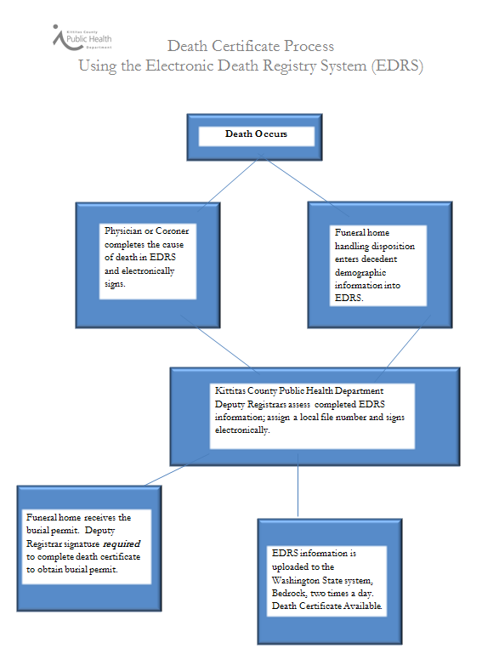

Kittitas County Public Health Department (KCPHD)
Investigation Protocol
Annex K

I. PURPOSE:
The purpose of this protocol is to establish the necessary procedures for the investigation of suspected outbreaks and clusters of communicable diseases, and environmental public health hazards to ensure timely investigations. The investigation protocol delineates responsibilities as well as steps to investigate the issue along with reporting requirements.
KCPHD will follow appropriate procedures and notification practices when investigating complaints and reports of health problems and occupational public health hazards. KCPHD will notify and provide direction to appropriate persons/agencies throughout the investigation process.
II. SCOPE
This protocol applies to any incident in Kittitas County that requires investigation of suspected or identified public health hazards. These hazards include environmental health incidents as well as disease reports. Investigations may range from investigating a suspected case patient, to a cluster (3 patients), or potential outbreak (5 patients). A cluster evaluation may be differentiated from an outbreak in that a single case of some infectious disease may trigger the use of outbreak protocol.
III. PLANNING ASSUMPTIONS
KCPHD does not have the capacity, beyond initial response and assessment, to conduct additional studies or etiological investigations.
KCPHD cannot conduct multiple, simultaneous in-person investigations due to limited personnel. KCPHD Administrator, Health Officer, or Supervisory staff may assign employees to investigate incidents, even if the nature of said incidents are outside the normal purview of the responding staff. For example, non-medical staff may conduct phone interviews in regard to infectious disease exposure.
Depending on the nature of the investigation, KCPHD may involve KSCO or Code Enforcement to assist with compliance issues.
III. RESPONSIBILTIES:
A. KCPHD will be responsible for the following activities as the lead investigative agency for public health hazards or diseases:
- For all complaints and reports of communicable disease and/or occupational health hazards received by KCPHD, KCPHD will document pertinent information of any potential or verified health issue or incident.
- Diseases that are communicable will be assigned to the Community Health Supervisor. Environmental Health issues will be assigned to the Environmental Health Supervisor. Supervisors may choose to investigate or delegate the investigation to an employee, preferably within that program.
  - Depending on the breadth and urgency of the investigation, outside agencies, such as DOH or Ecology, may be involved.
  - Food Borne Illness investigations will be led by KCPHD staff with Food Inspector training and will follow established DOH protocols.
- KCPHD will conduct interviews with reporting party.
  - If the original complaint or report does not warrant an investigation, interviews may not be conducted.
- KCPHD investigating staff will refer to DOH guidelines regarding reporting procedures, if required.
- KCPHD will be responsible for contacting and updating all regulatory agencies if necessary.
- KCPHD will provide education to partners and providers, as necessary, specific to the hazard or identified disease.
- Investigating staff will notify Health Officer, Administrator, and CH/EH Supervisors of health issues or incidents that require Health Orders, or subsequent compliance checks.
- KCPHD will compile information on health issues or incidents and provide updates to public/agencies as needed. An After Action Report may be required if an investigation resulted in an Order.
- Determination of follow-up that is necessary will be discussed and implemented by Investigating Staff, CH/EH Supervisors, Public Health Administrator, and Public Health Officer.

IV. CONCEPT OF OPERATIONS:
Protocol for disease investigation may include disease specific procedures outlined by the Washington State Department of Health, contact management, clinical management, mitigation, use of prophylaxis, laboratory coordination, and/or the use of legal authorities for public health hazards or disease control. KCPHD will follow the procedural steps below:
